

Design and Implementation of an IoT-Enabled Online Hotel Management and Reservation System

OLATUNBOSUN DAVID ENIOLA – 22/3058
ONYENSO IFEDAYO CHIBUDOM – 22/2157

A PROJECT WORK SUBMITTED IN PARTIAL FULFILLMENT OF THE REQUIREMENTS FOR THE AWARD OF A BACHELOR OF SCIENCE B.SC (HONS) DEGREE IN COMPUTER SCIENCE

TO THE DEPARTMENT OF COMPUTER SCIENCE, SCHOOL OF COMPUTING, BABCOCK UNIVERSITY, ILISHAN-REMO, OGUN STATE, NIGERIA

DECLARATION

We declare that this project work, titled Design and Implementation of an IoT-Enabled Online Hotel Management and Reservation System, was carried out by the following students:

OLATUNBOSUN ENIOLA DAVID __________________
22/3058 SIGNATURE/DATE

ONYENSO IFEDAYO CHIBUDOM __________________
22/2157 SIGNATURE/DATE

CERTIFICATION
We hereby certify that this project was carried out by the underlisted students under the supervision of the Department of Computer Science, School of Computing, Babcock University, Ilishan-Remo, Ogun State, Nigeria.

OLATUNBOSUN ENIOLA DAVID-22/3058
ONYENSO IFEDAYO CHIBUDOM-22/2157

DR OLAWALE SOMEFUN _______________
(PROJECT SUPERVISOR) DATE/SIGNATURE
EXTERNAL SUPERVISOR ________________
DATE/SIGNATURE
DR OLUWASEUN EBIESUWA _________________
(HOD Computer Science) DATE/SIGNATURE

DEDICATION

This project is dedicated first to God Almighty, whose grace, strength, and guidance sustained us throughout the course of this work. We also dedicate it to our supervisor, Dr. Olawale Somefun, and to everyone whose encouragement and support helped us bring the project to completion.
Also. We would like to dedicate this project to our supervisor, Dr. Olawale Somefun, whose guidance and encouragement have played a role in helping us complete this work successfully. Your patience and unwavering support have truly motivated us during this journey. We will forever be grateful. We dedicate this project to our parents and guidance for the significant part they played throughout our academic journey. Your sacrifice, love, encouragement, and support have been our source of determination and commitment, and certainly don’t go unnoticed. Thank you very much for all you do for us.
May God bless and continually keep and empower you all in all your endeavors in Jesus’ name. Amen.

ACKNOWLEDGEMENT
We sincerely appreciate everyone who contributed to the successful completion of this project. Above all, we thank God Almighty for His grace, mercy, and guidance throughout the course of this work. We are deeply grateful to our project supervisor, Dr. Olawale Somefun, for his patient guidance, constructive feedback, and encouragement. We also appreciate our parents, family members, friends, classmates, and lecturers for their support, prayers, and motivation. Every form of help we received played an important part in bringing this project to completion.
This project would not have been possible without all your support. Thank you and we are forever grateful.

ABSTRACT
The hospitality industry depends on timely reservation handling, accurate room-status control, secure payment processing, and coordinated staff workflow. This project presents the design and implementation of an IoT-enabled online hotel management and reservation system developed to improve hotel operations while strengthening health, safety, and environmental awareness. The system was built with Django, HTML, CSS, and JavaScript, and it supports room browsing, online and offline booking, Paystack-backed payment processing, role-based access control, custom administrative and receptionist dashboards, housekeeping coordination, and simulated IoT room monitoring. The monitoring module tracks conditions such as temperature, gas level, and motion activity, stores sensor readings, and generates alerts when abnormal situations are detected. The completed system demonstrates how hotel administration and smart monitoring can be integrated into a single platform that improves operational efficiency, accountability, and guest safety. Overall, the project provides a practical prototype for smarter hotel management and a strong foundation for future real-world deployment.
Keywords: hotel management system, IoT monitoring, reservation system, Paystack payment, role-based access control, HSE alerting.

TABLE OF CONTENTS
Update the table to display the final contents.
Update the table to display the final contents.

CHAPTER ONE: INTRODUCTION

CHAPTER ONE: INTRODUCTION

1.0 Background of the Study

The hospitality industry has undergone a tremendous transformation over the past few decades, driven largely by globalization and technological advancement. The integration of Information and Communication Technologies (ICT) has revolutionized hotel operations, enabling better management of reservations, customer services, and administrative processes (Koh & Hassim, 2021). Traditionally, hotels relied on manual systems for handling bookings, check-ins, check-outs, and record keeping. These manual methods were often prone to human error, data loss, delays, and inefficient coordination among hotel staff.

As digital transformation accelerates across industries, hotels have increasingly adopted online management systems to streamline their operations and enhance customer satisfaction. Online hotel management and reservation platforms allow guests to make bookings remotely while enabling administrators to manage room allocations, guest information, and reporting in real time (Hu & Gu, 2013). Such systems minimize human error, reduce administrative workload, and improve overall operational efficiency.
In recent years, the emergence of the Internet of Things (IoT) has further transformed the hospitality sector. IoT technologies enable hotels to integrate smart sensors, automated control systems, and real-time monitoring to enhance both operational efficiency and guest comfort. For example, IoT-enabled systems can automatically manage room temperature, lighting, energy usage, and even occupancy detection, creating a more personalized and efficient guest experience (Liu, Zhang, & Chen, 2024).

Beyond comfort and convenience, IoT also plays a crucial role in enhancing hotel security. Incidents of violence, unauthorized entry, and emergencies in hotel rooms have highlighted the need for proactive safety measures. Through the integration of IoT-based motion detection systems, hotels can automatically identify unusual activities or sudden movements, triggering alerts for security personnel. This capability helps prevent criminal acts, respond swiftly to emergencies, and ensure the safety of both guests and staff.

The aim of this project is to design and implement an IoT-enabled online hotel management and reservation system that improves hotel operations, strengthens record management, supports secure booking and payment workflows, and enhances safety through room-condition monitoring.
The aim of this project is to design and implement an IoT-enabled online hotel management and reservation system that improves hotel operations, strengthens record management, supports secure booking and payment workflows, and enhances safety through room-condition monitoring.

1.1 Problem Statement

1.1 Problem Statement

The hospitality industry continues to face multiple operational and safety challenges despite technological progress. Many hotels, particularly small and medium-sized establishments, still rely on manual or semi-automated management systems, which are prone to human error, data redundancy, delayed processing, and inefficient room management. These inefficiencies lead to poor customer experiences, inaccurate record keeping, and difficulties in managing peak periods.

Furthermore, hotel security and safety have become growing concerns due to reported incidents such as unauthorized room access, violent altercations, and even fatalities occurring within hotel premises. Traditional surveillance systems often lack real-time detection and automated alerts, resulting in delays that can endanger guests and staff.

Despite the availability of smart hotel technologies, there is still a lack of systems that prioritize HSE practices. In essence, hotels often struggle with:

• Delayed hazard detection (fire, gas leaks, water leakage)
• Manual record-keeping for HSE compliance
• Poor monitoring of indoor air quality and environmental safety
• Inefficient emergency response systems

These challenges increase the risk of accidents, regulatory violations, and reputational damage. Therefore, there is a need for an IoT-based hotel management system that actively promotes HSE compliance and reduces human error.

1.2 Significance of the Study

1.2 Significance of the Study
This study aims to contribute to the modernization of hotel management systems by integrating IoT technologies to create a more efficient, secure, and personalized hospitality experience. The significance of this research is outlined as follows:

1.2.1 For Hotel Management
The system will automate several hotel operations, including reservations, check-ins, and record management, reducing human error and improving administrative efficiency. Through IoT-based sensors, management will have access to real-time data for room occupancy, environmental conditions, and security alerts.

1.2.2 For Guests
Guests will benefit from improved convenience and safety. IoT-enabled motion detection systems will help ensure personal safety by identifying and alerting staff to unusual activities or emergencies within the premises.

1.2.3 For Researchers and Developers
The study will serve as a valuable reference for future research on the integration of IoT technologies in hospitality and other service-oriented industries. It also provides a foundation for developing more intelligent, data-driven, and secure management systems.

1.2.4 For Society
By promoting smarter and safer hotel environments, this system contributes to broader technological advancement in the tourism and service industries. It enhances customer trust, improves health and safety standards, and supports digital transformation within the hospitality sector.

1.3 Aim and Objectives

1.3 Aim and Objectives
The main aim of this project is to design and implement an online hotel management and reservation system enhanced with IoT automation capabilities.
The specific objectives include:

- To develop a secure, web-based system for online hotel booking, room allocation, and administrative management.
- To implement IoT-enabled features for real-time room monitoring such as
gas leakage detection , air quality/temperature control, and occupancy detection.
- To design a centralized database system for efficient storage, retrieval, and reporting of hotel records, including guests, reservations, payments, and room status.
- To integrate secure authentication and payment processing mechanisms to protect user data and ensure safe online transactions.

- To implement real-time alert and notification systems for staff using IoT data (e.g., fire alerts, abnormal temperature, unauthorized access).
- To improve hotel safety by integrating Health, Safety, and Environmental (HSE) measures such as smoke detection, gas leakage monitoring, and emergency response triggers.

- To provide administrative analytics and reporting dashboards to aid management in tracking performance, occupancy rates, and resource utilization.
- To ensure system scalability and reliability to accommodate future expansion of hotel branches and additional IoT devices.

1.4 Scope of the Study
This study focuses on the design and implementation of an online hotel management and reservation system with integrated IoT-style monitoring. The system covers room browsing, online and offline booking, role-based dashboards, payment processing, customer record management, housekeeping coordination, and room-condition alerts based on simulated sensor data. The work does not extend to full smart-building automation, multi-branch deployment, or physical hardware installation at production scale. Its emphasis is on a functional academic prototype that demonstrates both hotel operations and safety-aware monitoring in one platform.
This study focuses on the design and implementation of an online hotel management and reservation system with integrated IoT-style monitoring. The system covers room browsing, online and offline booking, role-based dashboards, payment processing, customer record management, housekeeping coordination, and room-condition alerts based on simulated sensor data. The work does not extend to full smart-building automation, multi-branch deployment, or physical hardware installation at production scale. Its emphasis is on a functional academic prototype that demonstrates both hotel operations and safety-aware monitoring in one platform.

The system was implemented with HTML, CSS, JavaScript, and Django-based templates on the frontend, while Python and Django were used for backend logic, routing, model management, and authentication. SQLite served as the prototype database, Paystack was integrated for online payment verification, and the IoT component was implemented through simulated monitoring services that generate room-condition data for dashboard display and alert handling. This combination made it possible to demonstrate the intended workflow end to end within a realistic academic prototype.
The development process followed the major SDLC stages of requirement analysis, system design, implementation, testing, and documentation.
The development process followed the major SDLC stages of requirement analysis, system design, implementation, testing, and documentation.

1.6 Definition of Terms
    - Internet of Things (IoT): A network of interconnected devices capable of collecting and exchanging data in real time.
    - Hotel Management System: A software application that manages hotel operations such as booking, billing, and customer management.
    - Reservation System: A component that allows users to make, modify, and cancel room bookings online.
    - Hotel Management System: A software solution designed to manage hotel operations such as booking, check-in/check-out, billing, and record keeping.
    - Online Reservation: A process that allows customers to book hotel rooms over the internet.
    - Database: A structured collection of data that can be accessed, managed, and updated electronically.
    - Automation: The use of technology to perform tasks with minimal human intervention.
    - User Interface (UI): The visual part of the system that allows users to interact with the application.

CHAPTER TWO: LITERATURE REVIEW

2.0 Overview of Hotel Management Systems
A hotel is a commercial establishment that provides paid lodging on a short-term basis. Hotels play an important role in the tourism and hospitality industry by creating jobs, supporting travel, generating revenue, and contributing to local economic activity.

2.0 Overview of Hotel Management Systems
A hotel is a commercial establishment that provides paid lodging on a short-term basis. Hotels play an important role in the tourism and hospitality industry by creating jobs, supporting travel, generating revenue, and contributing to local economic activity.
A hotel management system (HMS) is a software application that helps hotels to manage the operations. HMS typically includes modules for front office management, housekeeping management, food and beverage management, accounting, and inventory management.
A management system is a set of policies, processes, and procedures used by an organization to achieve its objectives. Management systems can be applied to all aspects of an organization's operations. Hassan and Osman (2023) stated that Management systems are typically based on the Plan-Do-Check-Act (PDCA) cycle, which is a continuous improvement process. The PDCA cycle involves the following steps:
1. Plan: The organization set objectives and develops plans to achieve those objectives.
2. Do: The organization implements the plans.
3. Check: The organization monitors the implementation of the plans and measures progress towards the objectives.
4. Act: The organization takes corrective action to address any gaps between the actual and planned performance.

A hotel reservation system (HRS) can be defined as a computerized or online application that automates the process of booking rooms, managing guest information, and handling payments. Its main purpose is to provide a more efficient, reliable, and accessible alternative to manual booking systems, allowing hotels to manage inventory, process reservations, and enhance customer service.

2.1 Evolution of Hotel Management Systems

Hotel operations were once managed through paper ledgers, wall charts, manual cashbooks, and face-to-face front-desk communication. Those methods were workable for small guest houses, but they became unreliable as hotels needed faster room turnover, better audit trails, and clearer visibility into who was arriving, departing, or owing payment. Manual systems also made it difficult to coordinate between reception, management, and support staff in real time.
The first wave of computerized hotel tools focused mainly on digitizing bookings, room allocation, and billing. Later web-based systems expanded that scope by allowing public room browsing, remote reservation, and centralized staff access. In the current stage of development, hospitality software is expected to do more than store data. It is increasingly judged by how well it supports live decisions, role-specific dashboards, secure payment confirmation, and operational monitoring across the property.

2.2 Core Functions in Contemporary Hotel Applications

A modern hotel platform usually combines several responsibilities inside one workflow. It must manage room inventory, customer identity, booking windows, check-in and check-out events, payment state, and staff activity. These modules are tightly connected. A booking affects room status. A payment event affects confirmation state. A checkout event affects housekeeping readiness. Good software reflects these dependencies instead of treating each activity as a disconnected form.
Another major expectation in current systems is role separation. Guests need simple room discovery and reservation pages. Administrators need a strategic view of rooms, users, employees, revenue-related figures, and alerts. Reception staff need a narrow but faster operational view that emphasizes today's arrivals, departures, room readiness, guest search, and pending payments. When those views are not separated properly, the system becomes cluttered and slows down the users who depend on it most.

2.3 Smart Hotel Monitoring and HSE Awareness

Smart-hotel thinking adds a second layer to ordinary hotel management: visibility into what is happening physically inside the building. Temperature drift, gas leakage, unusual motion, or device silence may all be operationally important even when the reservation records look normal. This matters because a room can be correctly marked as occupied or available while still presenting an environmental or security risk that staff should respond to quickly.
In many academic and prototype environments, real sensors are not always available. Even so, simulated monitoring remains valuable when it is designed responsibly. A simulation can still model the logic of device registration, payload generation, threshold evaluation, alert persistence, acknowledgement, and resolution. In that sense, a simulation-driven IoT layer is still useful for demonstrating how HSE monitoring can be embedded into hotel workflow rather than left as a theoretical add-on.

2.4 Observed Gaps in Existing Approaches
A recurring weakness in many hotel software examples is that the guest-facing booking experience is improved while the internal operating experience remains shallow (Priyadharshini and Catherine, 2021). Systems often allow room reservation, yet provide limited support for receptionist-specific actions such as fast guest lookup, guided check-in and check-out, housekeeping follow-up, or monitoring of unsettled payments. That gap matters in practice because reception is where operational delays become visible first.
A second gap is the weak connection between payment confirmation and booking persistence (Eftekhar et al., 2022). In many simplified prototypes, payment is discussed conceptually but not handled as an actual control point in the reservation lifecycle. A third gap is the separation of safety monitoring from normal hotel software. When room-condition alerts live outside the same application that manages bookings and staff actions, accountability becomes weaker and response time may suffer.
Table 2.1: Comparison of traditional hotel handling, ordinary web tools, and the present integrated project.
Dimension | Traditional hotel handling | Ordinary web hotel tool | Present project
Reservation capture | Desk ledger or phone call | Online form only | Online form plus validated booking workflow
Payment linkage | Manual reconciliation | Sometimes external to reservation logic | Paystack verification tied to booking confirmation
Staff access | Verbal coordination | Often one generic admin view | Separated admin and receptionist dashboards
Room turnover visibility | Paper notes or memory | Partial status visibility | Room state and housekeeping status stored together
Safety awareness | Manual observation | Usually absent | Simulated IoT monitoring with persistent alerts

2.5 Relevance to the Present Project

The current project responds directly to those gaps by combining public room discovery, structured online booking, Paystack-backed payment verification, administrative control, receptionist workflow support, and an IoT-style monitoring module inside one Django application. This makes the system stronger as a project document because the chapters can discuss a single integrated platform rather than unrelated feature demonstrations.
The project is also relevant as a smart-hospitality prototype. It shows that even without physical hardware devices, a system can still preserve the end-to-end monitoring pattern: assign a logical device to each room, generate or receive readings, evaluate them against room context, raise alerts, and expose those alerts on operational dashboards. That integration is the main conceptual strength of the work and is what distinguishes it from a basic booking website.

2.6 Conclusion
The literature and practice background reviewed in this chapter point to a clear direction: hotel software is most useful when it connects reservations, payments, staff workflow, and operational visibility in one coherent system. This project follows that direction. The next chapter therefore explains how the system was designed and implemented as a structured web application with both transactional and monitoring responsibilities.

CHAPTER THREE: SYSTEM ANALYSIS AND DESIGN

CHAPTER THREE: SYSTEM ANALYSIS AND DESIGN

3.1 Research Design

In developing this software, an iterative approach guided by Agile principles was adopted. This model was suitable because the project combines several connected modules, including guest booking, room management, payment processing, receptionist operations, housekeeping support, and IoT-based monitoring. Working in iterations made it possible to build the core workflow first and then refine the dashboards, alert logic, and supporting operational features as the system matured.

This approach aligns well with the changing demands of hotel software. By dividing development into manageable stages, the team could focus on one feature area at a time, gather feedback, test progress, and improve the system continuously without losing sight of the overall objective.

This approach aligns well with the changing demands of hotel software. By dividing development into manageable stages, the team could focus on one feature area at a time, gather feedback, test progress, and improve the system continuously without losing sight of the overall objective.
The iterative approach was especially useful because it allowed the project to remain realistic. For example, the payment flow was upgraded from a simple record-keeping idea into a Paystack-backed confirmation step, and the receptionist workflow evolved into a dedicated dashboard rather than remaining a generic admin extension. The same pattern applied to the HSE component, which matured from a concept into a database-backed monitoring subsystem.
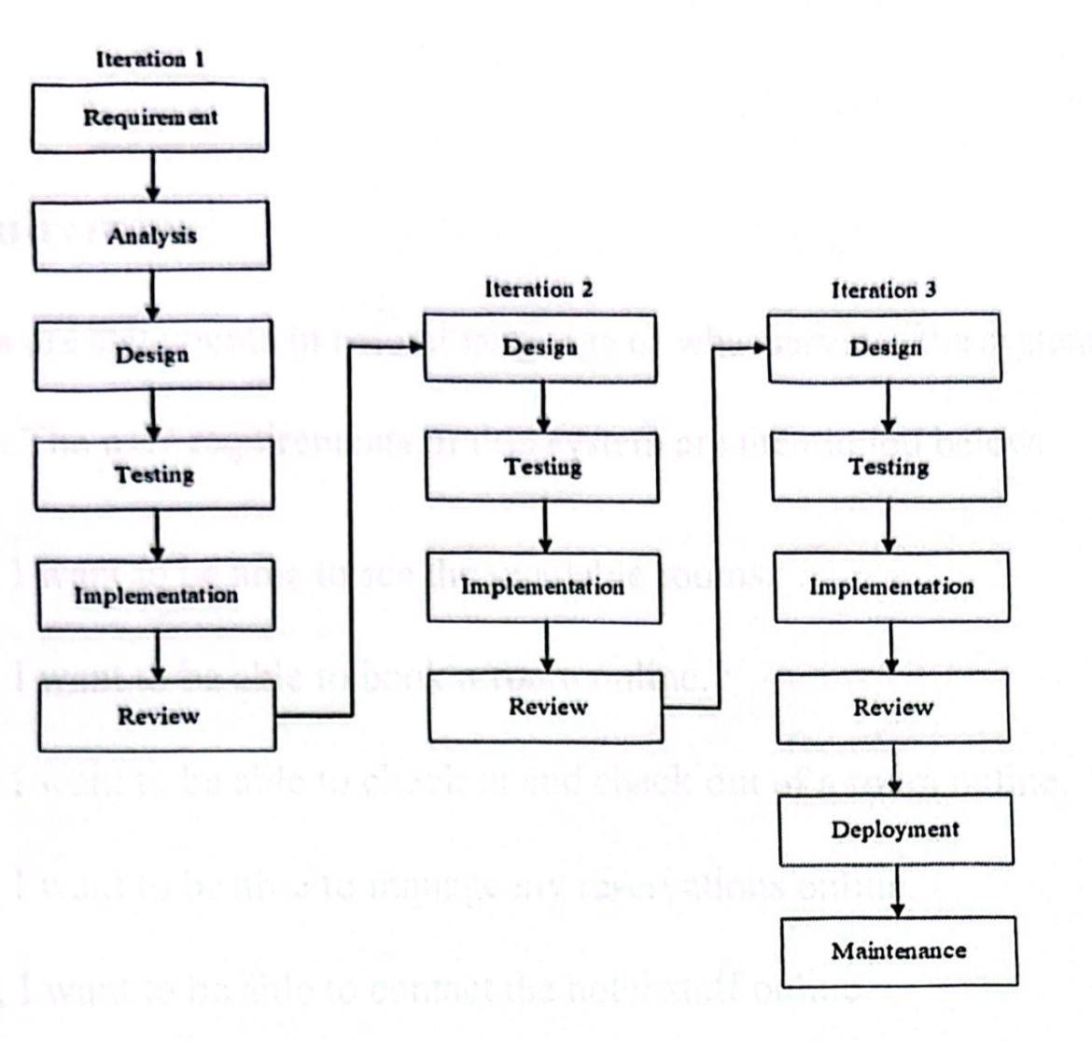
Figure 3.1 Javatpoint (2023) iterative Model diagram

3.2 Requirement Analysis

3.2 Requirement Analysis
Requirement gathering was guided by the actual roles represented in the system. Guests require visibility into available rooms, stay cost, booking dates, and account access. Administrators require deeper control over rooms, bookings, users, employees, salaries, and monitoring summaries. Reception staff requires quick-action tools for arrivals, departures, search, payments, and housekeeping coordination. The monitoring layer, though automated, behaves as another operational stakeholder because it continuously contributes room-condition events to the system.
Functional requirements were therefore grouped around role-specific outcomes rather than abstract menus. The system had to redirect users to the correct dashboard, prevent room clashes, preserve payment state, support room-status updates, create housekeeping tasks after checkout, and evaluate simulated room-condition data against meaningful thresholds. Non-functional requirements were equally important: usability, role isolation, persistence, and maintainability were all necessary for the project to remain credible as a final-year system.
Table 3.1: Stakeholder groups and the interfaces that serve them in the implemented system.
Stakeholder | Primary responsibility in the system | Main interface focus
Guest | Browse rooms, submit reservations, review booking/payment state | Public pages and booking flow
Administrator | Monitor hotel-wide performance and manage operational records | Custom admin dashboard
Receptionist | Handle arrivals, departures, search, desk payment, and room readiness | Reception dashboard and boards
Monitoring service | Generate and evaluate room-condition readings | IoT dashboard and alert center

The architecture follows a standard layered Django pattern. The presentation layer is formed by HTML templates, Bootstrap-driven layout elements, and page-specific CSS or JavaScript enhancements. The application layer contains the view logic, validation rules, role checks, session handling, and feature orchestration. The data layer is provided by Django models backed by SQLite for the prototype environment.

3.3 System Architecture
The architecture follows a standard layered Django pattern. The presentation layer is formed by HTML templates, Bootstrap-driven layout elements, and page-specific CSS or JavaScript enhancements. The application layer contains the view logic, validation rules, role checks, session handling, and feature orchestration. The data layer is provided by Django models backed by SQLite for the prototype environment.
The architecture is deliberately split across two application domains. The `HotelApp` module handles users, rooms, bookings, payments, employees, salaries, housekeeping tasks, and activity logs. The `alerts` module manages logical devices, sensor readings, alert lifecycle, notification records, and monitoring snapshots. This split keeps the smart-monitoring responsibilities close to the hotel workflow without allowing them to overwhelm the ordinary reservation code.

3.4 Unified Modelling Language (UML) Diagrams

3.4 Unified Modelling Language (UML) Diagrams
A UML diagram is a graphical language for communicating the result of any object-oriented analysis and design process. Unified Modeling Language (UML) is a standardized graphical language that provides a comprehensive set of diagrams for designing, visualizing, building, and documenting software systems, as well as business models and other non-software systems. There are different types of UML diagrams; for this system, the use case diagram and flow chart will be used.

3.4.1 Use Case Diagram

3.4.1 Use Case Diagram
A use case describes how the user interacts with the system to perform some activity. A use case diagram is a graphical representation of the services the system will provide. It consists of the following:

1. The actors: A person who derives benefit from the system, the users of the system.
2. A use case: A major piece of system functionality, the actions performed by the actors
3. A system boundary: Includes the name of the system inside or on top.
4. An association relationship: Links actors to the use case.
This system consists of four actors, which include the guests, the receptionist, and the system
Administrator and meal manager. The diagram below is the use case.

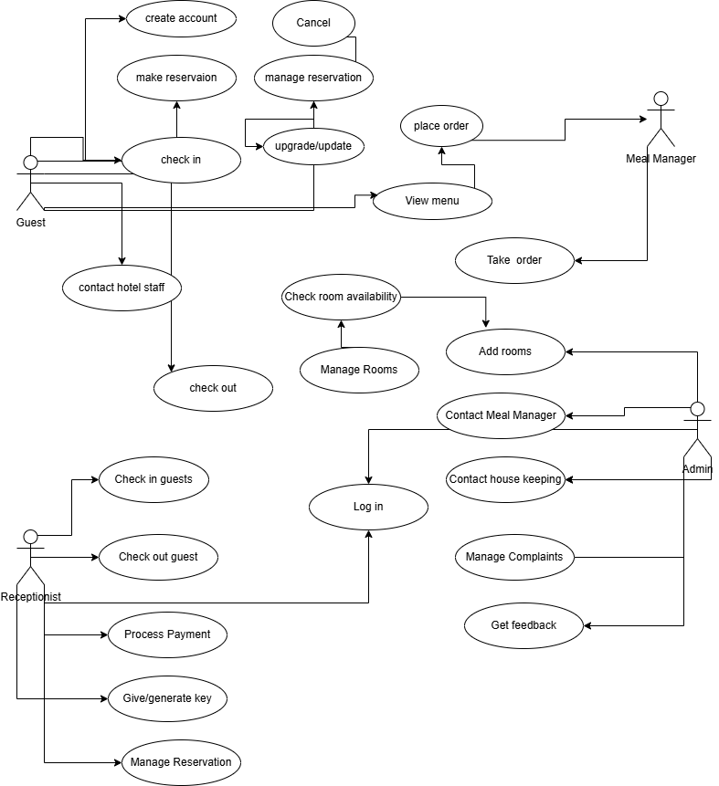
Figure 3.2 Use case diagram of a hotel management system

3.4.2 Activity Diagram

3.4.2 Activity Diagram
An activity diagram emphasizes the flow of control and data through a system in relation to time and sequence. It represents the flow from one activity to another within the system (Paul,2023).

Key characteristics that identify it as an activity diagram include:
1. The use of rounded rectangles to represent activities.
2. Diamond shapes which indicate decision points.
3. 4. Solid arrows representing the flow from one activity to the next.
The use of a black dot to indicate the start (initial node) and encircled black dots to
indicate the end (final nodes) of the flow.

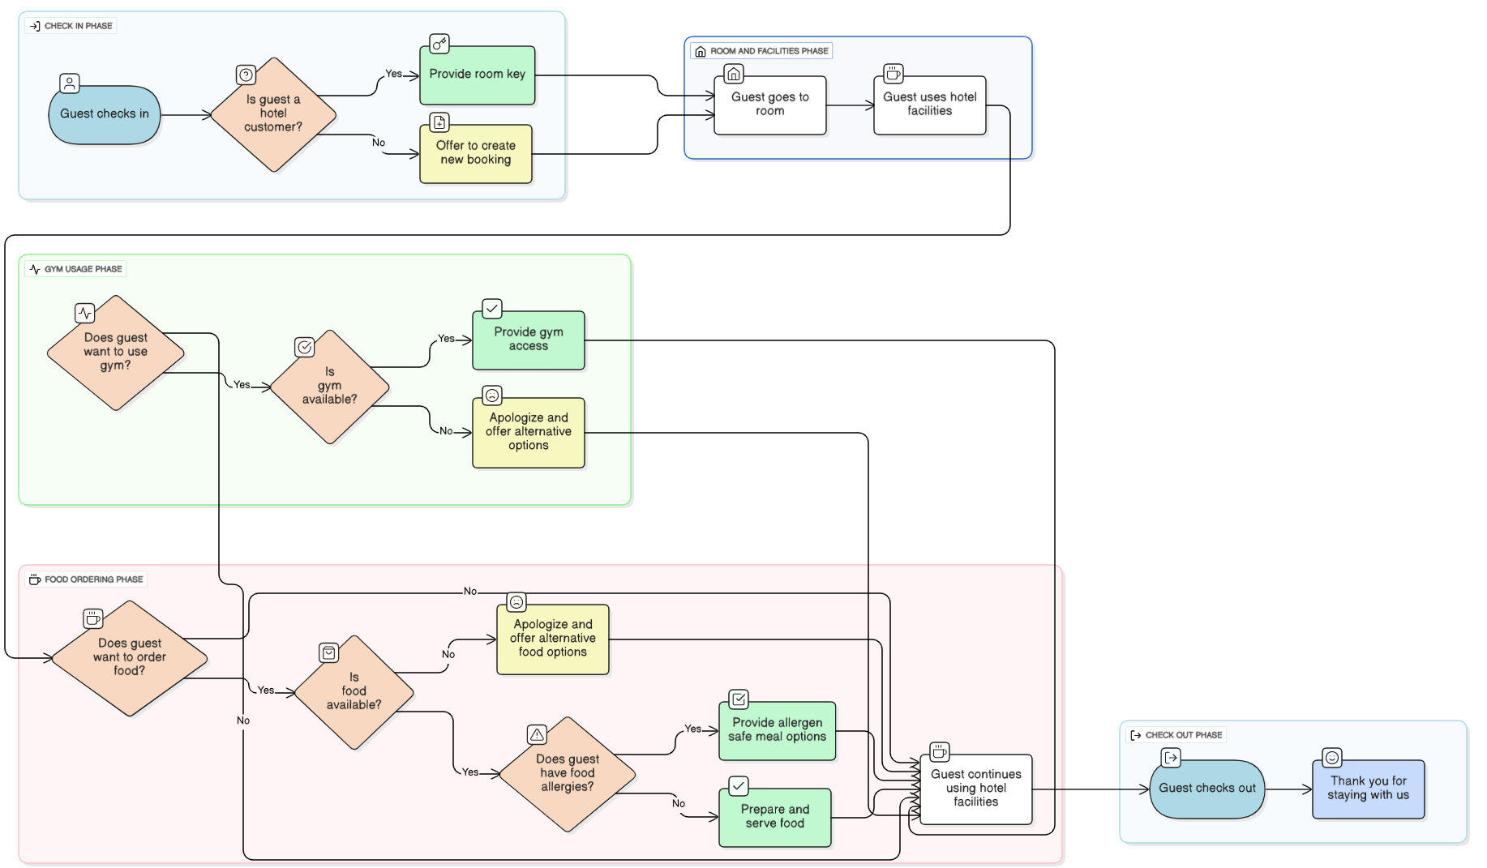
Figure 3.3 Activity diagram of a hotel management system

3.5 Data Design

3.5 Data Design
The data design of the project mirrors the operational relationships inside a hotel. Room records sit at the centre because both online and offline bookings depend on them, payments refer back to them indirectly through booking type and booking identifier, and housekeeping tasks are created around their turnover state. The custom user model adds role information that makes it possible to route administrators, reception staff, and guests differently after authentication.
For the monitoring subsystem, additional entities were introduced instead of overloading the ordinary hotel tables. Logical device records, sensor readings, room-condition alerts, and notification logs are persisted separately so that the monitoring lifecycle can be audited over time. That separation keeps the design clean and allows the HSE module to remain expandable if physical devices are later connected to the platform.

Table 3.2: Core persistent entities and their responsibilities in the current implementation.
Entity | Purpose in the implemented system
Authorregis | Custom email-based user model with receptionist and staff roles
Room | Stores room number, type, floor, facilities, price, availability, and housekeeping state
OnlineBooking | Persists guest-submitted reservations after successful payment
OfflineBooking | Persists front-desk or walk-in bookings
Employee | Stores hotel staff bio-data and department records used in operations
Salary | Stores compensation records linked to each employee entry
Payment | Tracks payment method, status, receipt, and Paystack references through booking_type and booking_id
HousekeepingTask | Coordinates room-turnover work after checkout or support actions
ActivityLog | Records important operational actions for audit and visibility
IoTDevice | Assigns a logical monitoring device to each room
SensorReading | Stores temperature, gas, motion, and overall room condition history
RoomConditionAlert | Stores active and resolved HSE incidents tied to readings
AlertNotification | Stores simulated email or SMS notices generated from room-condition alerts

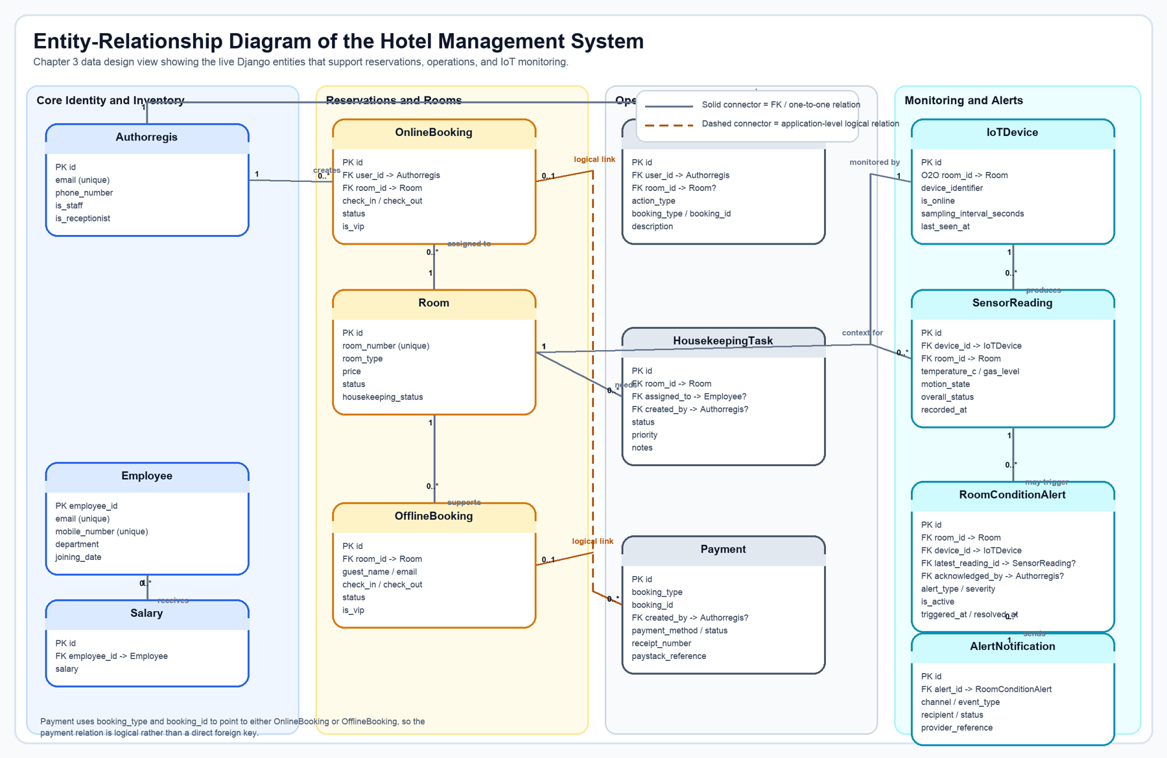

3.6 Workflow Design
Figure 3.1 complements Table 3.2 by showing the actual structural links behind the system. Solid connectors represent direct foreign-key or one-to-one relationships in the Django models, while the dashed payment connector highlights the current application's logical booking link implemented through `booking_type` and `booking_id` rather than a strict database foreign key.

3.6 Workflow Design
The public guest workflow begins with room browsing, continues into the booking form, validates stay dates and guest counts, stores a pending reservation in session, and then moves to the payment page. Only after payment verification does the system create the persistent booking record and mark the room as reserved. That sequence is important because it avoids the common prototype problem where bookings are written before payment outcome is known.

3.7 Development Tools and Environment

3.7 Development Tools and Environment

The implemented stack is centered on Python and Django. HTML, CSS, JavaScript, and template rendering support the interface. SQLite provides a lightweight but reliable persistence layer for the academic prototype. Paystack is used as the active payment gateway in the guest booking flow, while optional notification backends allow the monitoring module to record or dispatch alert messages.

1. FRONT END DEVELOPMENT - HTML, CSS, JavaScript:
HTML (Hypertext Markup Language): Utilized for structuring the content and layout of the web application, HTML forms the backbone of the user interface, defining the various elements and their relationships. CSS (Cascading Style Sheets): Responsible for the styling and presentation of the user interface, CSS enhances the visual appeal and ensures a consistent and professional look throughout the web application.

2. JavaScript: Employed for dynamic functionality, user interactions, and real-time updates,
JavaScript enhances the user experience by enabling responsive and interactive features within
the web application.

3. BACK-END DEVELOPMENT – PYTHON DJANGO:
4. Integrated Development Environment (IDE): Visual Studio Code was used as the main development environment for coding, debugging, and project organization. It supported a smoother workflow across the Django application, templates, and supporting scripts used in the implementation.

4. Integrated Development Environment (IDE): Visual Studio Code was used as the main development environment for coding, debugging, and project organization. It supported a smoother workflow across the Django application, templates, and supporting scripts used in the implementation.

5. VERSION CONTROL - Git: Git was utilized for version control, allowing for efficient collaboration among team members. It ensures that changes are tracked, facilitates
collaboration on different aspects of the project simultaneously, and provides a mechanism for code rollback if needed.

6. PAYSTACK – A payment gateway was implemented using Paystack to ensure user bookings before confirmation.

CHAPTER FOUR: SYSTEM IMPLEMENTATION AND RESULTS

CHAPTER FOUR: SYSTEM IMPLEMENTATION AND RESULTS

4.1 Implemented Feature Overview

The completed application is best understood as a connected hospitality platform made of seven visible feature areas: access control, room inventory, booking, payment, administration, reception workflow, and HSE monitoring. Each one is presented below with the same evidence pattern so that the reader can move naturally from interface to logic.
The system was developed using a layered architecture made up of the following components:

• Frontend Layer - HTML, CSS, JavaScript, and Django templates for user interaction.
• Application Layer - Django views, forms, models, and services handling business logic.
• Database Layer - SQLite for prototype storage of users, bookings, payments, tasks, and sensor data.
• Monitoring Layer - Python-based simulation and alert services for room-condition updates.
• Integration Layer - Paystack callback handling and configurable email/SMS notification support.
• Monitoring Layer - Python-based simulation and alert services for room-condition updates.

• Integration Layer - Paystack callback handling and configurable email/SMS notification support.
• User authentication and role-based access control.

• Room inventory, online booking, and offline booking management.
• Paystack payment verification workflow.
• Administrative dashboard and reporting views.
• Receptionist operations and housekeeping coordination.
• IoT monitoring and HSE alert management.
• Receptionist operations and housekeeping coordination.

• IoT monitoring and HSE alert management.

4.2 Feature Walkthrough
The subsections below present each major feature with the same structure: functional explanation, implementation note, interface evidence, process flow, and a short code extract from the current repository.

4.2.1 Login and Role-Based Access
The login module gives the system its operational shape because it determines what kind of interface the user sees after authentication. A guest should not land on a crowded control panel, and a receptionist should not be forced to navigate the same screen as a system administrator. The application therefore uses role-aware routing immediately after successful sign-in.
From a presentation standpoint, this feature matters because it is the entry point to every other workflow shown in the document. It demonstrates that the project is not a single flat website, but a structured application with clear access boundaries and user-sensitive navigation.
Implementation note: The implementation keeps the routing logic compact by using helper functions that choose a safe `next` destination or fall back to the correct dashboard for the current role.
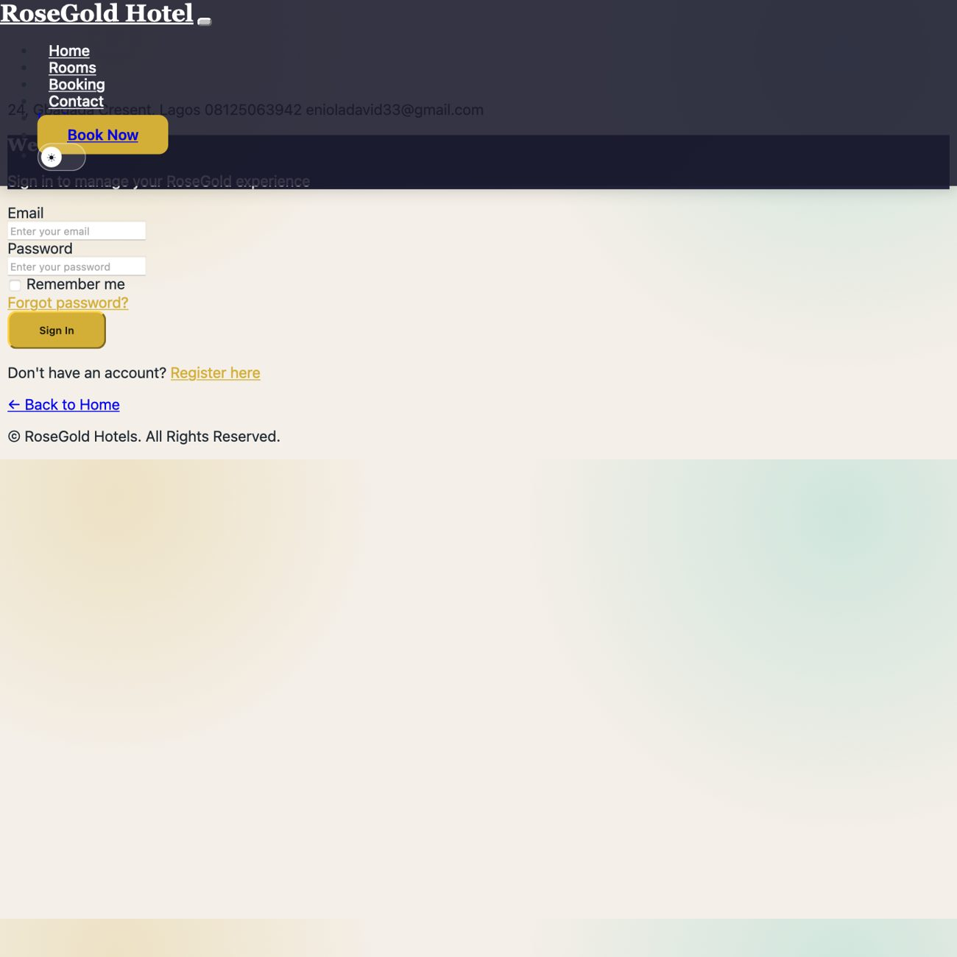
Figure 4.1: Login interface showing the email-based access form used to enter the hotel system.

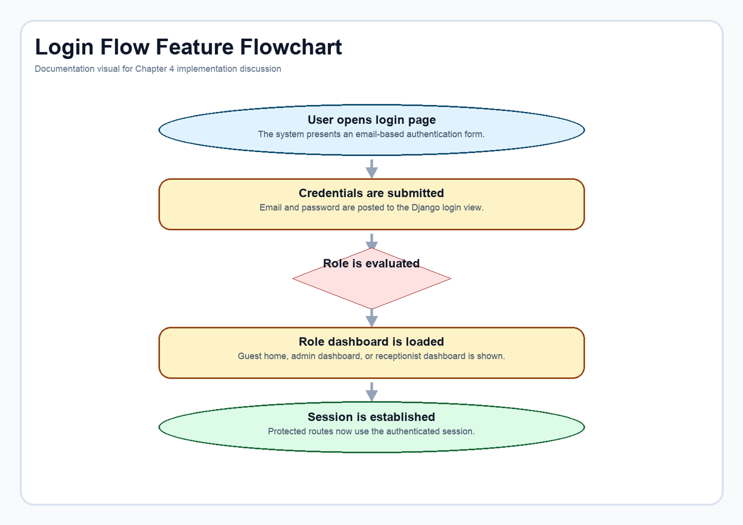
Figure 4.2: Role-aware login flow from credential submission to dashboard redirection.
Code extract: Role-aware redirect helper. This helper centralizes post-login routing and keeps redirection decisions predictable for guests, staff, and reception users. Source: Django_practice_Pro_hotel_management_system-main/HotelApp/views.py (lines 47-70).

def get_post_login_route_name(user):
if user.is_receptionist:
return "receptionist_dashboard"
elif user.is_staff:
return "dashboard"
else:
return "user_home"
def get_safe_next_url(request):
"""Return the ?next= redirect target if it is safe, otherwise return ''."""
next_url = request.POST.get("next") or request.GET.get("next", "")
if next_url and url_has_allowed_host_and_scheme(
next_url,
allowed_hosts={request.get_host()},
require_https=request.is_secure(),
):
return next_url
return ""
def get_post_login_redirect(request, user):
next_url = get_safe_next_url(request)
return next_url or reverse(get_post_login_route_name(user))

4.2.2 Rooms Catalogue and Room Management Context
The rooms feature is more than a gallery. It is the system's public inventory layer, and every booking, payment, dashboard summary, and room-status decision depends on it. The room records store pricing, room type, operational status, facilities, and housekeeping information, which means the same entity serves both guest-facing and staff-facing needs.
In the user experience, the room catalogue translates that stored information into a clear visual list. In the internal workflow, the same room model supports reservation checks, dashboard statistics, maintenance visibility, and turnover readiness.
Implementation note: The room model was designed with both commercial and operational fields so that one record can support public display, booking validation, and internal control views without duplicated data structures.
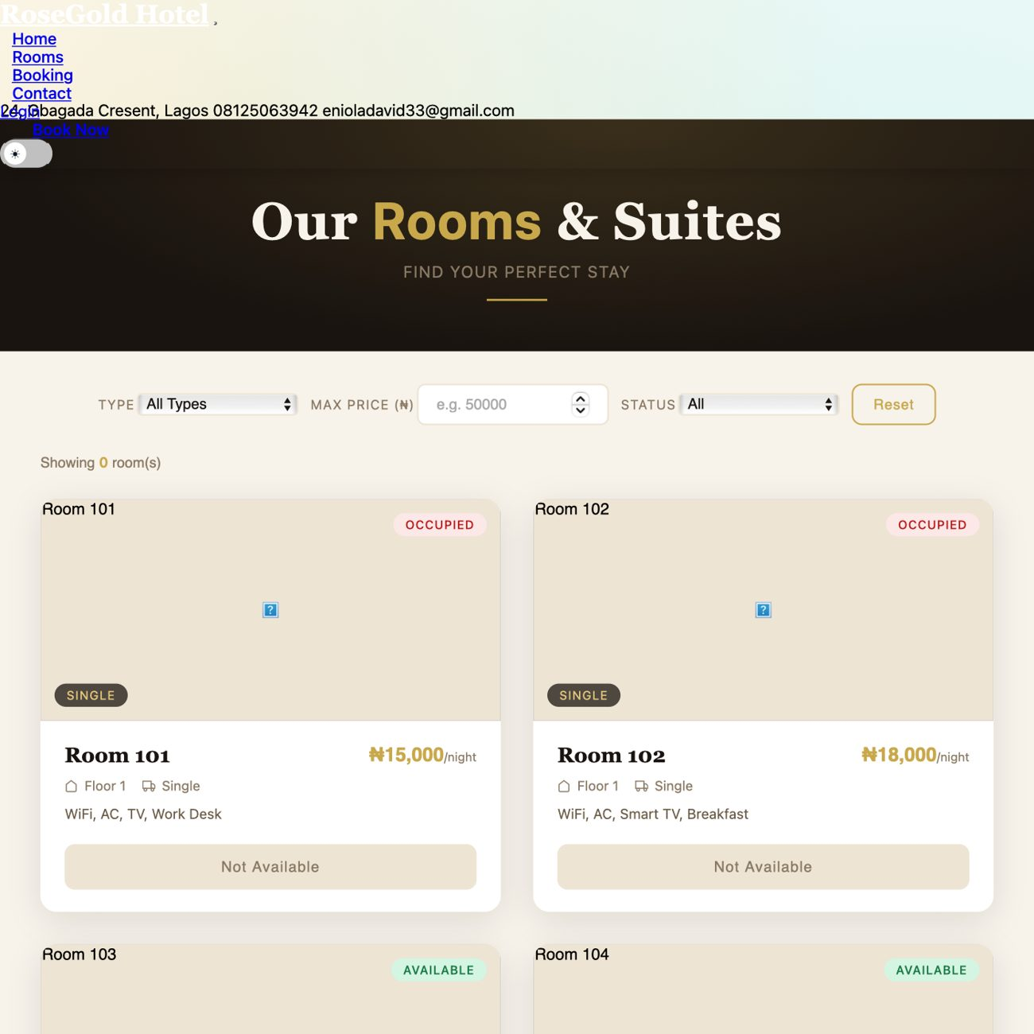
Figure 4.3: Public room catalogue showing room type, price, facilities, and current availability state.
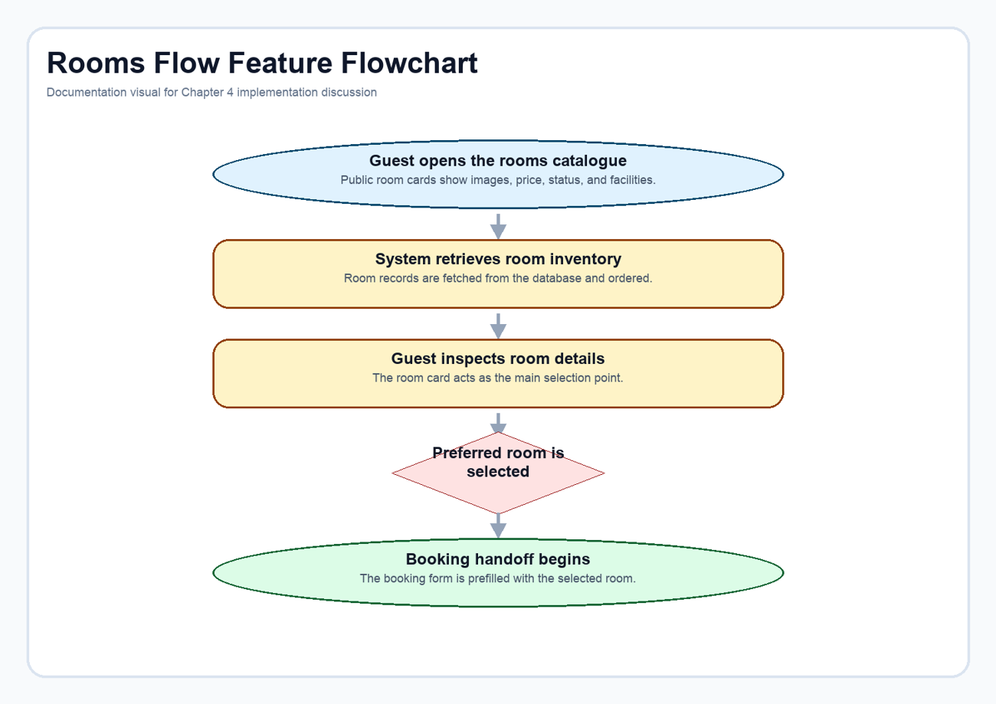
Figure 4.4: Room-discovery flow from public catalogue browsing to booking handoff.
Code extract: Core room model. This model defines the inventory attributes that drive both the catalogue view and the staff dashboards. Source: Django_practice_Pro_hotel_management_system-main/HotelApp/models.py (lines 57-89).

class Room(models.Model):
ROOM_STATUS = [
('available', 'Available'),
('occupied', 'Occupied'),
('maintenance', 'Maintenance'),
('reserved', 'Reserved'),
]
ROOM_TYPES = [
('single', 'Single'),
('double', 'Double'),
('suite', 'Suite'),
]
HOUSEKEEPING_STATUS = [
('clean', 'Clean'),
('dirty', 'Dirty'),
('in_progress', 'In Progress'),
]
room_number = models.CharField(max_length=50, unique=True)
room_type = models.CharField(max_length=20, choices=ROOM_TYPES, db_index=True)
floor = models.IntegerField()
facility = models.TextField()
price = models.DecimalField(max_digits=10, decimal_places=2)
image = models.ImageField(upload_to='rooms/', blank=True, null=True)
status = models.CharField(max_length=20, choices=ROOM_STATUS, default='available', db_index=True)
housekeeping_status = models.CharField(max_length=20, choices=HOUSEKEEPING_STATUS, default='clean')
last_cleaned = models.DateTimeField(blank=True, null=True)
created_at = models.DateTimeField(auto_now_add=True)
def __str__(self):
return f"Room {self.room_number} ({self.room_type})"

4.2.3 Booking Workflow
The booking workflow was implemented as a controlled sequence rather than a form that immediately creates a reservation record. The guest selects a room, chooses dates, enters occupancy details, and triggers server-side validation that checks date order and room-conflict conditions. Only when the booking data is valid does the system move it forward to the payment stage.
That approach improves reliability. It ensures that stay details are preserved long enough to support payment processing, yet the final booking record is not written prematurely. For a final-year project, this is a more realistic workflow than simply saving any submitted reservation request without transactional control.
Implementation note: The system stores the validated booking payload in session as `pending_booking`, which creates a clean handoff between booking validation and Paystack payment.
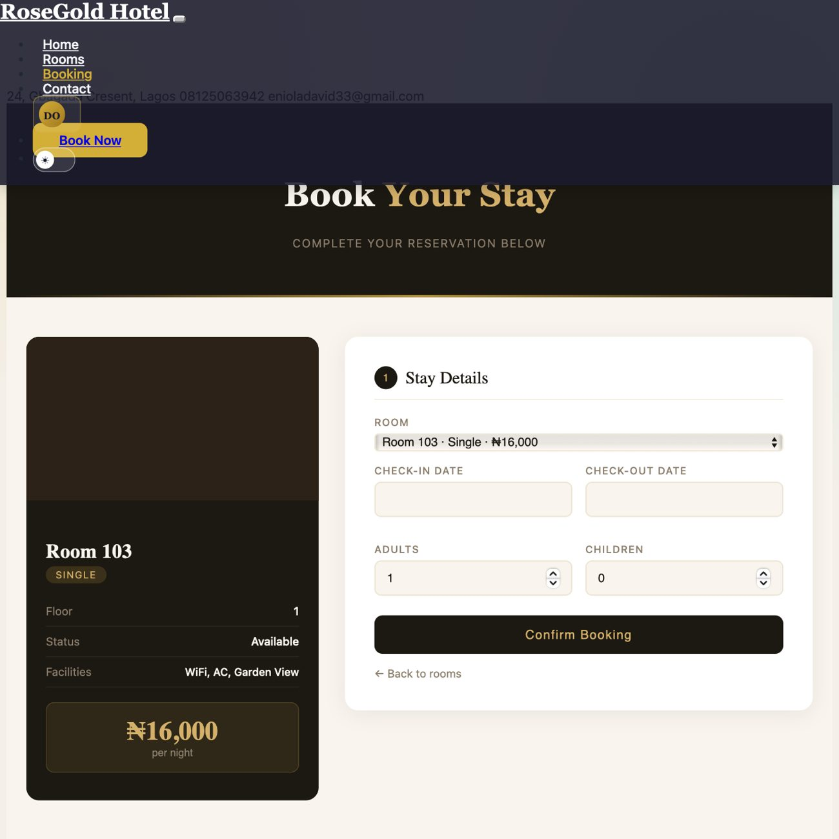
Figure 4.5: Booking page showing room context, date selection, and guest-count inputs before payment.

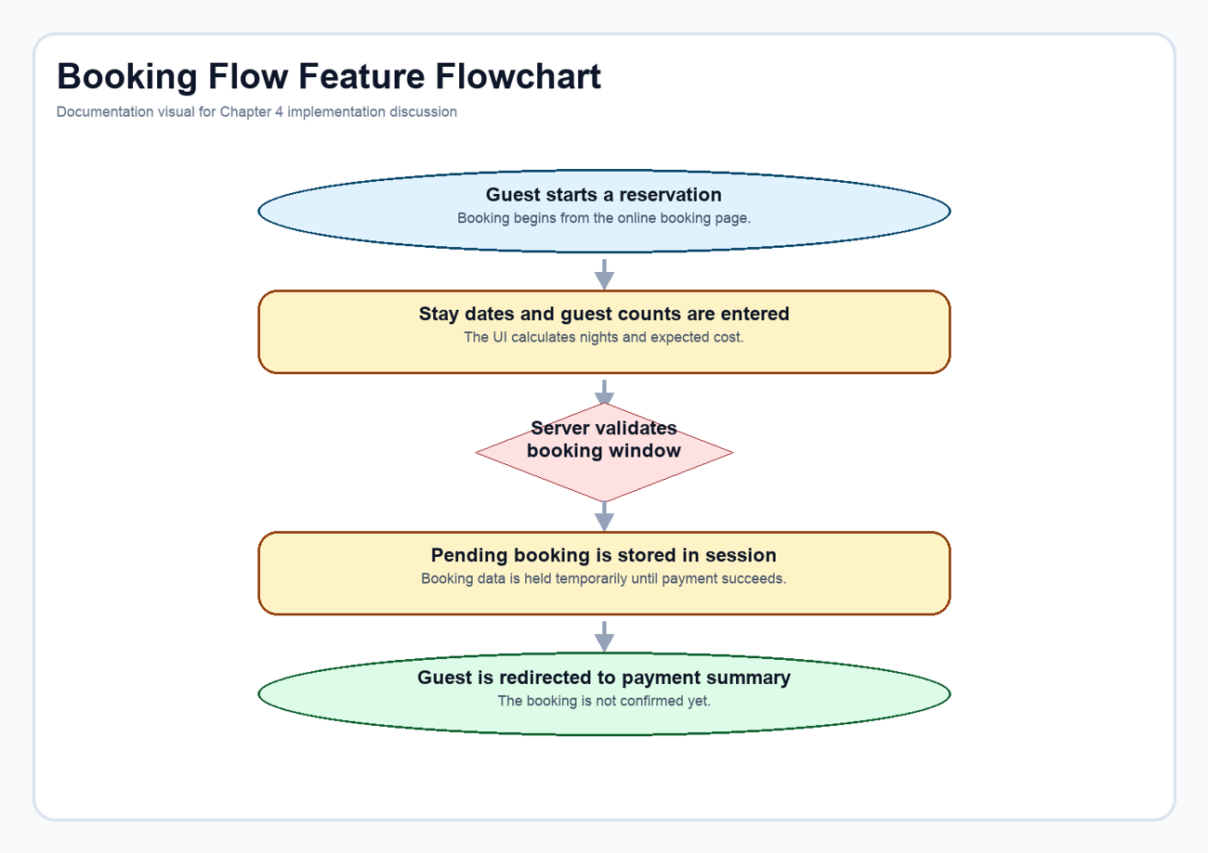
Figure 4.6: Validated booking flow from stay details to the pending-payment handoff.
Code extract: Booking validation and session handoff. This excerpt shows how the view validates user input and stores a pending booking in session before payment begins. Source: Django_practice_Pro_hotel_management_system-main/HotelApp/views.py (lines 521-558).
try:
check_in = datetime.strptime(form_data["check_in"], "%Y-%m-%d").date()
check_out = datetime.strptime(form_data["check_out"], "%Y-%m-%d").date()
except (TypeError, ValueError):
check_in = check_out = None
messages.error(request, "Please enter valid dates.")
try:
adults = int(form_data["adults"])
children = int(form_data["children"])
except (TypeError, ValueError):
adults = children = None
messages.error(request, "Please enter valid guest counts.")
if check_in and check_out and check_in >= check_out:
messages.error(request, "Check-out must be after check-in.")
if adults is not None and (adults <= 0 or children < 0):
messages.error(request, "Please enter valid guest counts.")
if selected_room and check_in and check_out and adults is not None:
if booking_window_has_conflict(selected_room, check_in, check_out):
messages.error(request, "Room is not available for the selected dates.")
else:
# Store booking data in session for payment processing
request.session['pending_booking'] = {
'room_id': selected_room.id,
'check_in': form_data["check_in"],
'check_out': form_data["check_out"],
'adults': adults,
'children': children,
'city': form_data["city"],
'country': form_data["country"],
'address': form_data["address"],
}
# Redirect to payment page instead of creating booking
return redirect("booking_payment_page")

4.2.4 Paystack Payment Workflow
Payment is an active part of the booking lifecycle in the current implementation. The guest reviews a structured payment summary and then proceeds through Paystack checkout. The application does not simply assume success; it initializes a transaction, stores a pending payment record, waits for the callback, verifies the returned reference, and only then creates the confirmed booking.
This feature significantly strengthens the realism of the project. It demonstrates how a hospitality system can connect booking data, payment state, activity logging, and room reservation status inside one workflow. It also shows that the platform has evolved beyond the earlier academic-prototype pattern of internal payment notes only.
Implementation note: The payment flow is split into two controlled stages: transaction initialization and callback verification. This allows booking creation to depend on server-side confirmation rather than on client-side assumption.
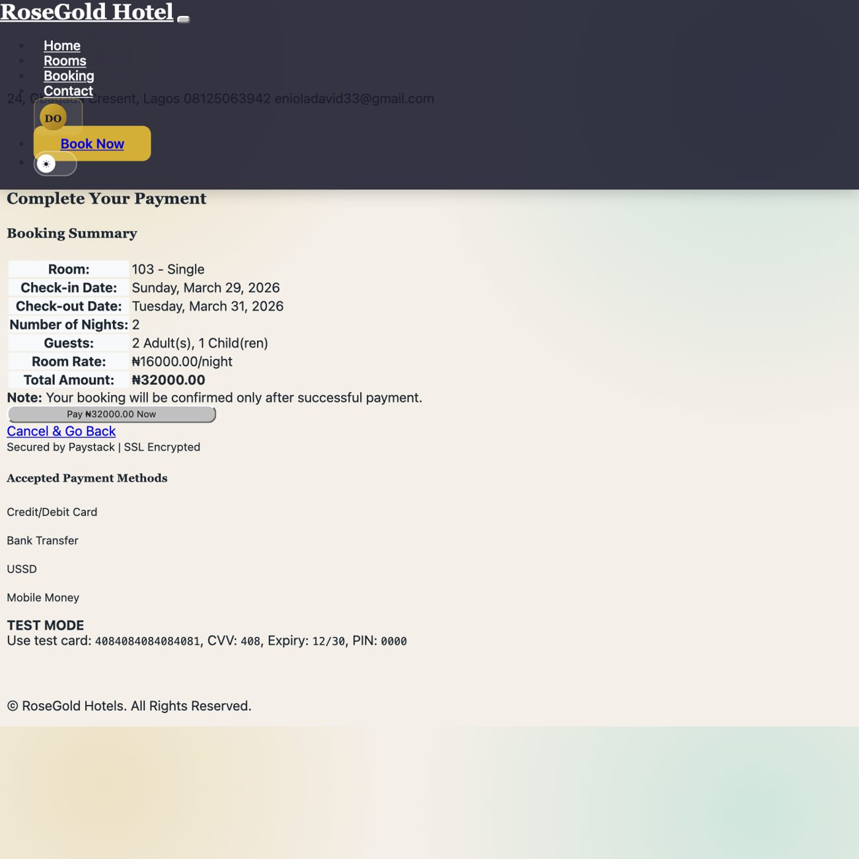
Figure 4.7: Payment summary page used to review reservation details before redirecting to Paystack.

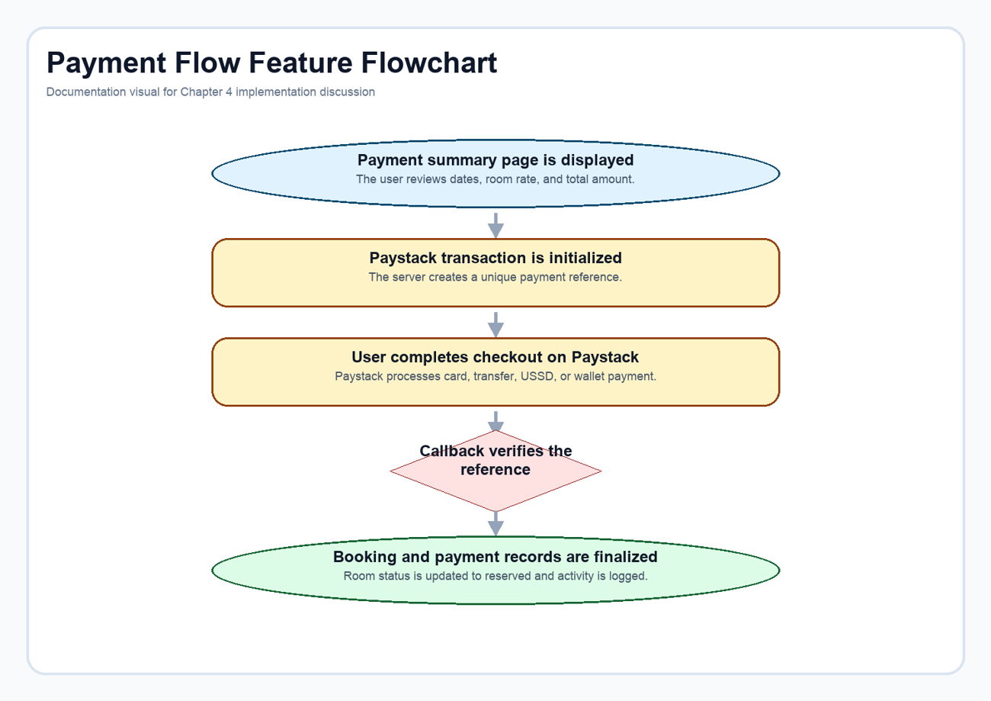
Figure 4.8: Paystack-backed payment sequence from pending booking to verified reservation.
Code extract: Paystack transaction initialization. The initialization stage calculates the payable amount, creates a unique reference, and opens a pending payment record before redirecting to Paystack. Source: Django_practice_Pro_hotel_management_system-main/HotelApp/views.py (lines 1414-1466).

@login_required
def initiate_payment(request):
"""Initialize Paystack payment for a booking"""
if request.method != 'POST':
return redirect('online_booking')
# Get booking details from session
booking_data = request.session.get('pending_booking')
if not booking_data:
messages.error(request, "No pending booking found. Please start booking process again.")
return redirect('online_booking')
try:
room = Room.objects.get(id=booking_data['room_id'])
check_in = datetime.strptime(booking_data['check_in'], '%Y-%m-%d').date()
check_out = datetime.strptime(booking_data['check_out'], '%Y-%m-%d').date()
# Calculate amount
nights = (check_out - check_in).days
amount = int(room.price * nights * 100) # Convert to kobo (Paystack uses kobo)
# Generate payment reference
reference = generate_payment_reference()
# Initialize Paystack transaction
paystack = Paystack(secret_key=settings.PAYSTACK_SECRET_KEY)
response = paystack.transaction.initialize(
email=request.user.email,
amount=amount,
reference=reference,
callback_url=request.build_absolute_uri(reverse('payment_callback'))
)
if response['status']:
# Store payment reference in session
request.session['payment_reference'] = reference
request.session['payment_amount'] = float(room.price * nights)
# Create pending payment record
Payment.objects.create(
booking_type='online',
booking_id=0, # Will be updated after booking creation
amount=room.price * nights,
payment_method='paystack',
payment_status='pending',
receipt_number=reference,
paystack_reference=reference,
paystack_access_code=response['data']['access_code'],
created_by=request.user
)
# Redirect to Paystack checkout
return redirect(response['data']['authorization_url'])

Code extract: Payment callback and booking confirmation. The callback stage verifies the reference, creates the final booking, updates the payment status, and reserves the room. Source: Django_practice_Pro_hotel_management_system-main/HotelApp/views.py (lines 1486-1523).
try:
# Verify payment with Paystack
paystack = Paystack(secret_key=settings.PAYSTACK_SECRET_KEY)
response = paystack.transaction.verify(reference=reference)
if response['status'] and response['data']['status'] == 'success':
# Get pending booking data
booking_data = request.session.get('pending_booking')
if not booking_data:
messages.error(request, "Booking data not found.")
return redirect('user_home')
# Create the booking
room = Room.objects.get(id=booking_data['room_id'])
booking = OnlineBooking.objects.create(
user=request.user,
room=room,
check_in=booking_data['check_in'],
check_out=booking_data['check_out'],
adults=booking_data.get('adults', 1),
children=booking_data.get('children', 0),
city=booking_data.get('city', ''),
country=booking_data.get('country', ''),
address=booking_data.get('address', ''),
status='confirmed'
)
# Update payment record
payment = Payment.objects.get(paystack_reference=reference)
payment.booking_id = booking.id
payment.payment_status = 'paid'
payment.paid_at = timezone.now()
payment.paystack_response = response['data']
payment.save()
# Update room status
room.status = 'reserved'
room.save()

4.2.5 Administrative Dashboard
The custom administrative dashboard acts as the management cockpit of the system. It brings together booking totals, room availability, occupancy rate, user counts, salary figures, booking trends, and recent monitoring alerts inside a single page. This gives administrators a working picture of the hotel's current state instead of forcing them to inspect isolated tables one by one.
The dashboard is especially important in this project because it also bridges ordinary hotel operations with smart monitoring. The HSE summary appears in the same space as the business metrics, which reinforces the idea that safety is an operational concern rather than a side system.
Implementation note: The dashboard view aggregates counts, trend values, revenue estimates, and IoT summaries directly from the database so that the page behaves like a live operational dashboard rather than a static mock-up.
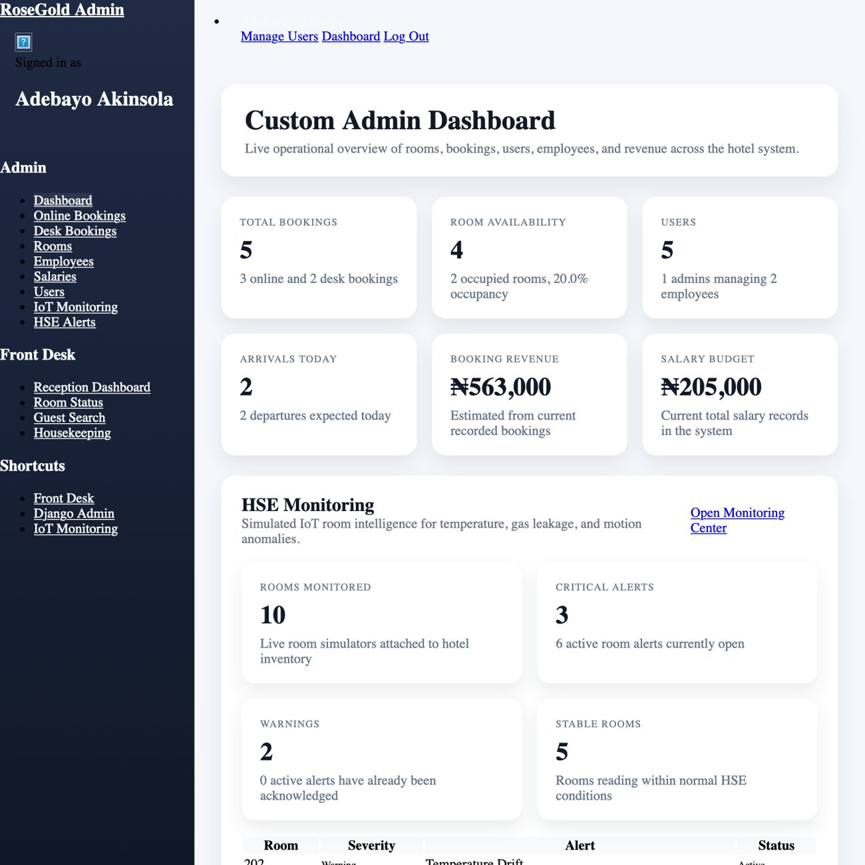
Figure 4.9: Custom administrator dashboard showing operational summaries and integrated HSE monitoring cards.
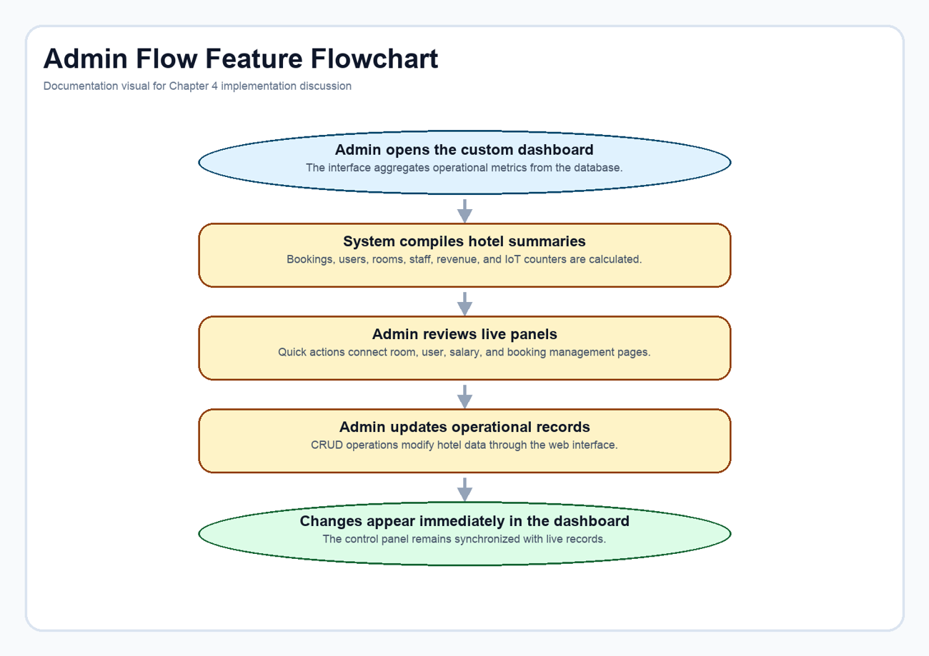
Figure 4.10: Administrative control flow from dashboard load to live management actions.
Code extract: Administrative metric aggregation. This excerpt shows how the dashboard compiles room, booking, user, revenue, and IoT summary values before rendering the page. Source: Django_practice_Pro_hotel_management_system-main/HotelApp/views.py (lines 177-233).

def dashboard(request):
today = timezone.localdate()
rooms = Room.objects.all()
users = Authorregis.objects.all()
employees = Employee.objects.all()
online_bookings = OnlineBooking.objects.select_related("user", "room")
offline_bookings = OfflineBooking.objects.select_related("room")
salaries = Salary.objects.select_related("employee")
room_status_counts = {
"Available": rooms.filter(status="available").count(),
"Occupied": rooms.filter(status="occupied").count(),
"Maintenance": rooms.filter(status="maintenance").count(),
}
occupied_room_ids = set(
online_bookings.filter(check_in__lte=today, check_out__gt=today).values_list("room_id", flat=True)
)
occupied_room_ids.update(
offline_bookings.filter(check_in__lte=today, check_out__gt=today).values_list("room_id", flat=True)
)
total_rooms = rooms.count()
total_online_bookings = online_bookings.count()
total_offline_bookings = offline_bookings.count()
total_bookings = total_online_bookings + total_offline_bookings
total_users = users.count()
total_staff_users = users.filter(is_staff=True).count()
total_guest_users = users.filter(is_staff=False).count()
total_employees = employees.count()
available_rooms = rooms.filter(status="available").count()
occupancy_rate = round((len(occupied_room_ids) / total_rooms) * 100, 1) if total_rooms else 0
check_ins_today = online_bookings.filter(check_in=today).count() + offline_bookings.filter(check_in=today).count()
check_outs_today = online_bookings.filter(check_out=today).count() + offline_bookings.filter(check_out=today).count()
booking_labels, online_booking_series = monthly_totals(online_bookings, "created_at")
_, offline_booking_series = monthly_totals(offline_bookings, "created_at")
booking_series = [online + offline for online, offline in zip(online_booking_series, offline_booking_series)]
account_distribution_labels = ["Admins", "Guests", "Employees"]
account_distribution_values = [total_staff_users, total_guest_users, total_employees]
estimated_revenue = calculate_booking_revenue(online_bookings.select_related("room")) + calculate_booking_revenue(
offline_bookings.select_related("room")
)
monthly_salary_budget = sum((salary.salary for salary in salaries), Decimal("0"))
iot_summary = None
recent_iot_alerts = []
try:
from alerts.services import build_monitoring_snapshot
from alerts.runtime import run_monitoring_cycle
run_monitoring_cycle(force_refresh=False)
iot_snapshot = build_monitoring_snapshot(force_refresh=False)
iot_summary = iot_snapshot["summary"]
recent_iot_alerts = iot_snapshot["alerts"][:5]

4.2.6 Receptionist Dashboard and Front-Desk Operations
The receptionist module was designed around day-to-day front-desk work rather than broad system administration. The dashboard emphasizes what matters during live operations: today's check-ins, today's check-outs, room statistics, pending housekeeping, recent activity, revenue collected today, and pending payments. This keeps the screen practical for front-desk decision making.
The workflow continues into related pages such as room status, guest search, housekeeping, check-in, check-out, and desk payment processing. In other words, the receptionist dashboard is not merely a smaller admin dashboard. It is a role-specific workspace tuned for speed, visibility, and frequent actions.
Implementation note: The receptionist view computes operational metrics around the current date and combines reservation queues with room status and payment summaries so that staff can act from one compact page.
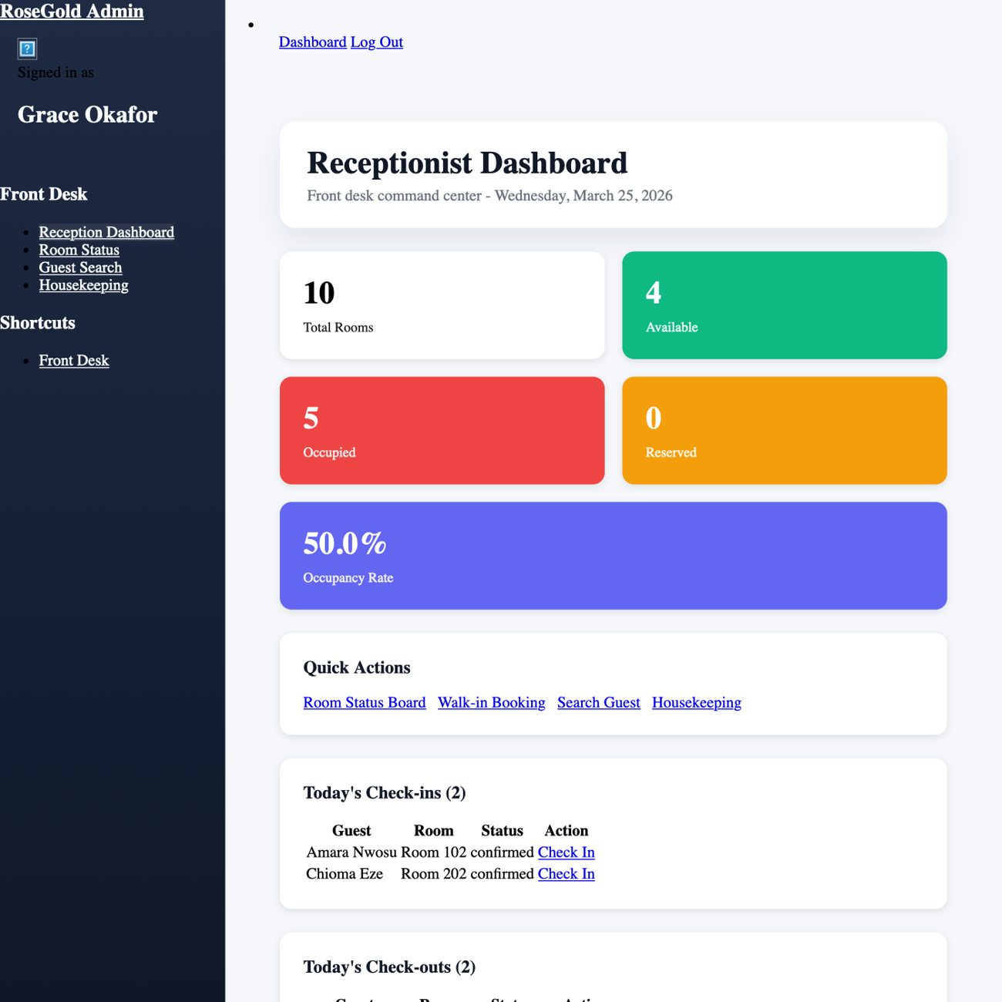
Figure 4.11: Receptionist dashboard focused on arrivals, departures, room status, and front-desk quick actions.
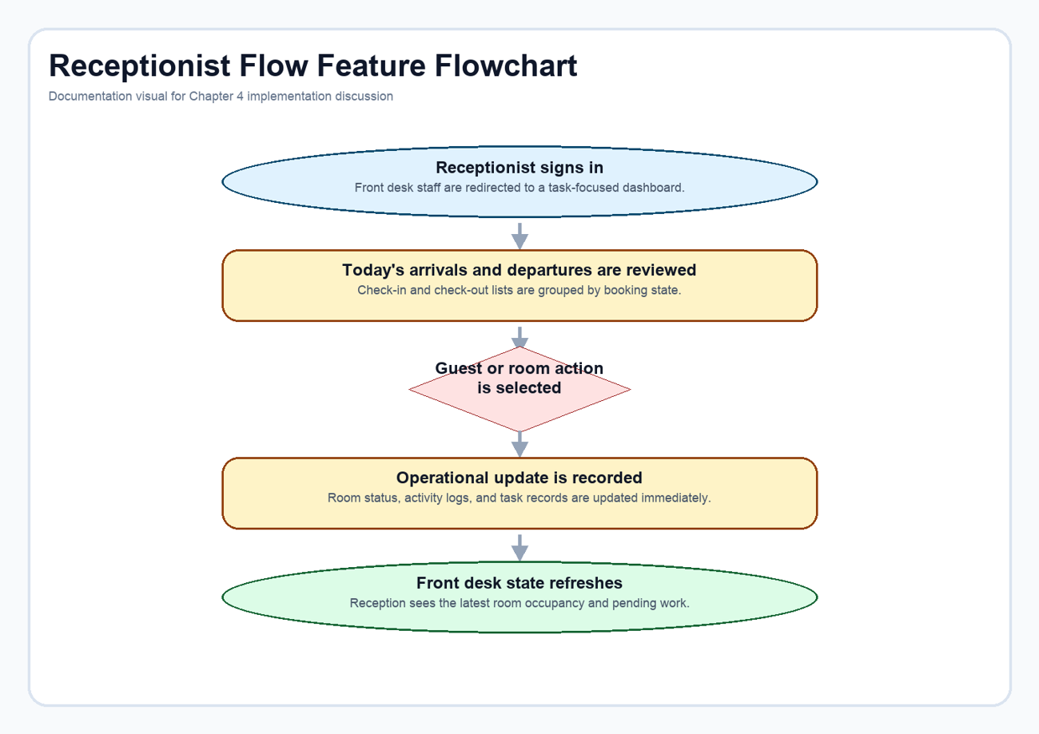
Figure 4.12: Front-desk workflow from sign-in through room, guest, and housekeeping actions.

Code extract: Receptionist dashboard aggregation. This view builds the arrival/departure queues, room statistics, and payment summaries that make the receptionist interface task-oriented. Source: Django_practice_Pro_hotel_management_system-main/HotelApp/views.py (lines 963-1038).
@receptionist_required
def receptionist_dashboard(request):
today = timezone.localdate()
now = timezone.now()
# Today's check-ins and check-outs
todays_checkins_online = OnlineBooking.objects.filter(
check_in=today,
status__in=['confirmed', 'pending']
).select_related('user', 'room').order_by('created_at')
todays_checkins_offline = OfflineBooking.objects.filter(
check_in=today,
status__in=['confirmed', 'pending']
).select_related('room').order_by('created_at')
todays_checkouts_online = OnlineBooking.objects.filter(
check_out=today,
status='checked_in'
).select_related('user', 'room').order_by('created_at')
todays_checkouts_offline = OfflineBooking.objects.filter(
check_out=today,
status='checked_in'
).select_related('room').order_by('created_at')
# Room statistics
total_rooms = Room.objects.count()
available_rooms = Room.objects.filter(status='available').count()
occupied_rooms = Room.objects.filter(status='occupied').count()
reserved_rooms = Room.objects.filter(status='reserved').count()
maintenance_rooms = Room.objects.filter(status='maintenance').count()
# Housekeeping tasks
pending_housekeeping = HousekeepingTask.objects.filter(
status='pending'
).select_related('room').order_by('-priority', 'created_at')[:5]
# Recent activity
recent_activities = ActivityLog.objects.select_related('user', 'room').order_by('-created_at')[:10]
# Revenue today
today_payments = Payment.objects.filter(
paid_at__date=today,
payment_status='paid'
).aggregate(total=Sum('amount'))
revenue_today = today_payments['total'] or Decimal('0.00')
# Guests in house
guests_in_house = OnlineBooking.objects.filter(status='checked_in').count() + \
OfflineBooking.objects.filter(status='checked_in').count()
# Pending payments
pending_payments_count = Payment.objects.filter(payment_status='pending').count()
context = build_admin_context(
"receptionist_dashboard",
todays_checkins_online=todays_checkins_online,
todays_checkins_offline=todays_checkins_offline,
todays_checkouts_online=todays_checkouts_online,
todays_checkouts_offline=todays_checkouts_offline,
total_rooms=total_rooms,
available_rooms=available_rooms,
occupied_rooms=occupied_rooms,
reserved_rooms=reserved_rooms,
maintenance_rooms=maintenance_rooms,
occupancy_rate=round((occupied_rooms / total_rooms * 100), 1) if total_rooms > 0 else 0,
pending_housekeeping=pending_housekeeping,
recent_activities=recent_activities,
revenue_today=revenue_today,
guests_in_house=guests_in_house,
pending_payments_count=pending_payments_count,
today=today,
)
return render(request, "admin/ReceptionistDashboard.html", context)

4.2.7 IoT Monitoring and HSE Alerting
The IoT monitoring module is the most distinctive part of the project. Each room is mapped to a logical device, sensor readings are stored over time, and rules convert those readings into warning or critical conditions based on temperature, gas level, motion state, and expected occupancy. The result is a monitoring dashboard that behaves like a live operational subsystem rather than a decorative front-end panel.
The HSE value of the feature lies in persistence and lifecycle. The system does not merely flash a warning; it stores readings, opens alerts, allows acknowledgement, records resolution, and makes recent incidents visible to administrators. That history is important because hotel safety work depends on accountability, not on momentary visual effects.
Implementation note: The monitoring logic separates payload evaluation from persistence. That design keeps the thresholds explicit and allows the same alert lifecycle to work whether readings are simulated or later connected to real devices.
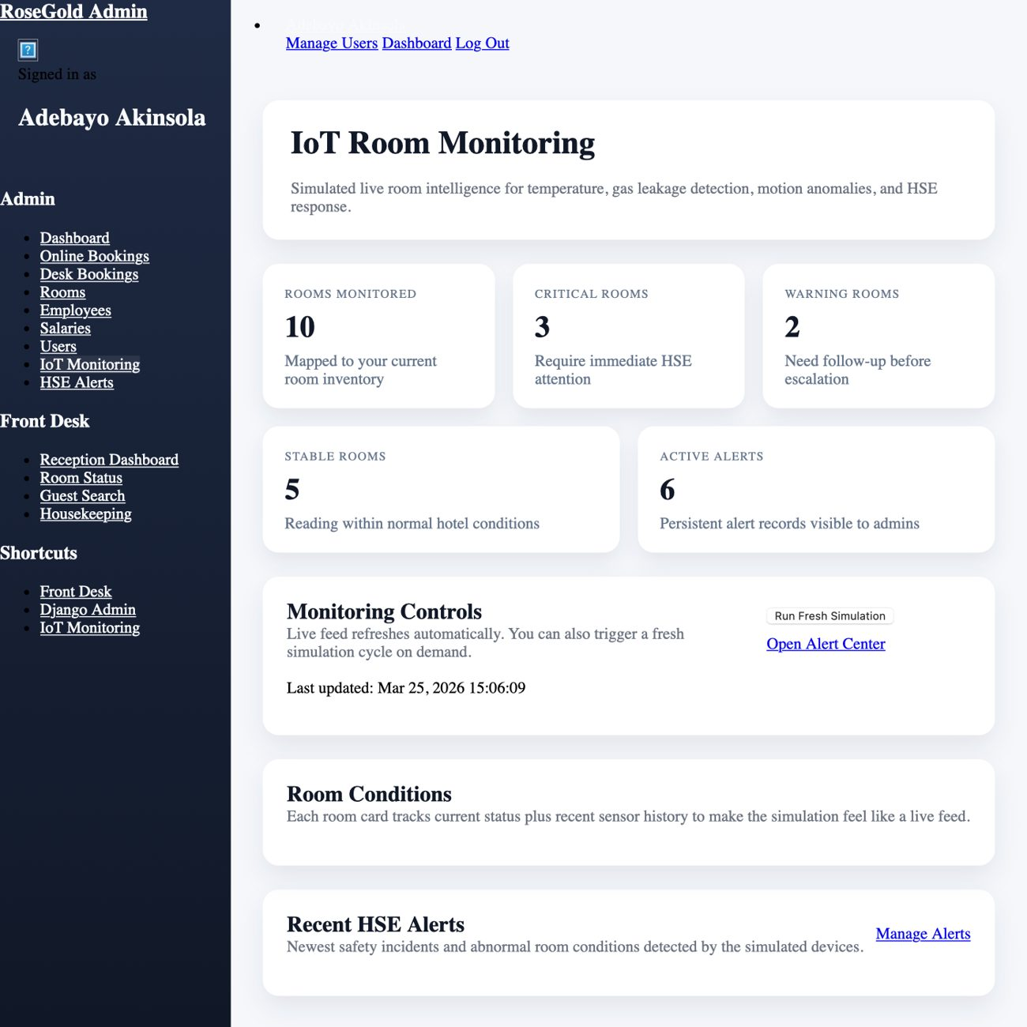
Figure 4.13: IoT monitoring dashboard showing room-condition summaries and active HSE alert counts.
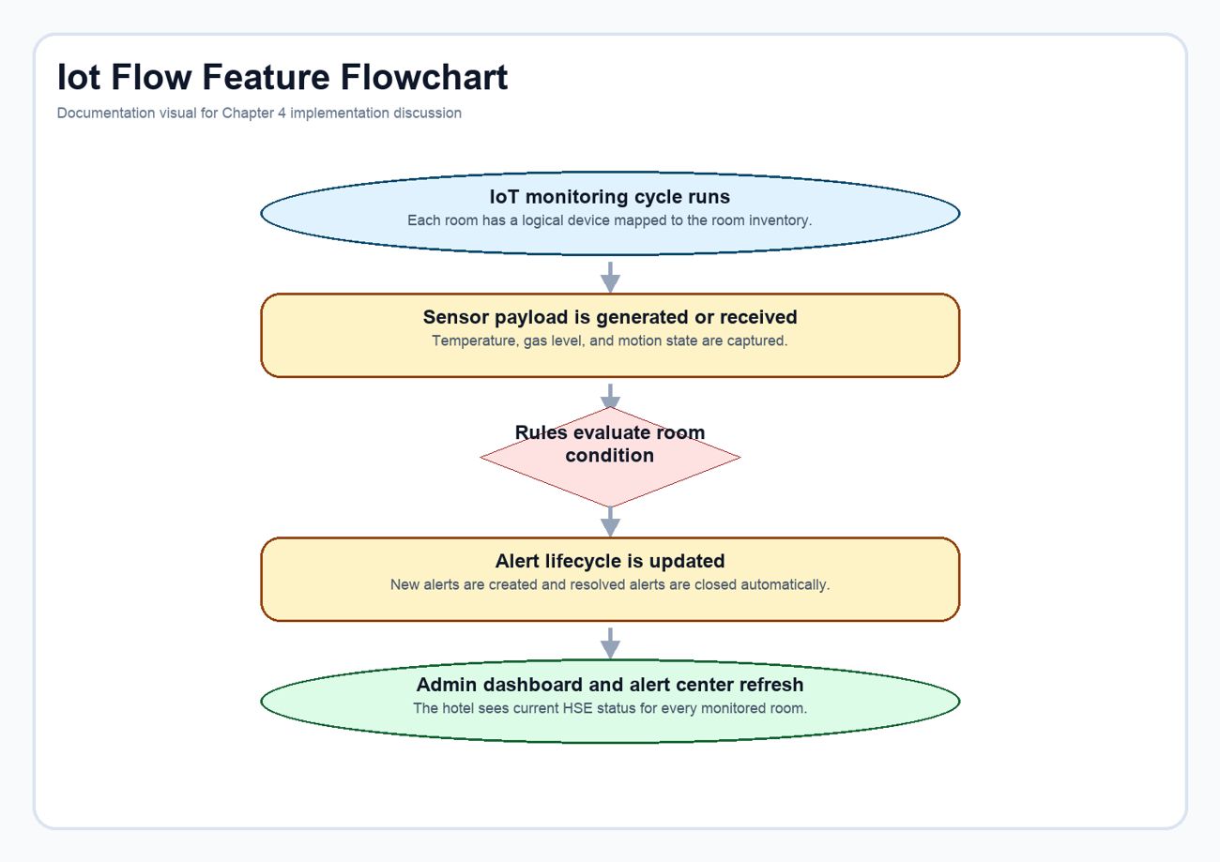
Figure 4.14: Monitoring lifecycle from sensor payload evaluation to alert refresh on the admin pages.
Code extract: Room-condition rule evaluation. The rule engine evaluates temperature, gas, and motion signals against room context to classify each reading as normal, warning, or critical. Source: Django_practice_Pro_hotel_management_system-main/alerts/services.py (lines 213-311).
def evaluate_payload(device, payload):
room = device.room
issues = []
temperature_c = payload["temperature_c"]
gas_level = payload["gas_level"]
motion_state = payload["motion_state"]
occupancy_expected = payload["occupancy_expected"]
low_warning = device.temperature_min_normal - 2.0
low_critical = device.temperature_min_normal - 4.0
high_warning = device.temperature_max_normal + 1.5
high_critical = device.temperature_max_normal + 3.5
if temperature_c <= low_critical or temperature_c >= high_critical:
issues.append(
{
"type": "temperature",
"severity": "critical",
"message": (
f"Room {room.room_number} temperature is {temperature_c}°C, "
f"outside the safe operating range."
),
}
)
elif temperature_c <= low_warning or temperature_c >= high_warning:
issues.append(
{
"type": "temperature",
"severity": "warning",
"message": (
f"Room {room.room_number} temperature is drifting at {temperature_c}°C "
f"and should be checked."
),
}
)
if gas_level >= device.gas_critical_threshold:
issues.append(
{
"type": "gas",
"severity": "critical",
"message": (
f"Room {room.room_number} gas concentration reached {gas_level} ppm. "
f"Immediate HSE response is recommended."
),
}
)
elif gas_level >= device.gas_warning_threshold:
issues.append(
{
"type": "gas",
"severity": "warning",
"message": (
f"Room {room.room_number} gas concentration is {gas_level} ppm, above the warning threshold."
),
}
)
if not occupancy_expected and motion_state == "tamper":
issues.append(
{
"type": "motion",
"severity": "critical",
"message": (
f"Tamper-level motion was detected in Room {room.room_number} while it should be secured."
),
}
)
elif not occupancy_expected and motion_state == "active":
issues.append(
{
"type": "motion",
"severity": "warning",
"message": (
f"Unexpected activity was detected in Room {room.room_number}. "
f"Front desk or security should confirm the room condition."
),
}
)
elif occupancy_expected and motion_state == "tamper":
issues.append(
{
"type": "motion",
"severity": "warning",
"message": (
f"Forceful motion signature was detected in occupied Room {room.room_number}. "
f"Please verify guest safety."
),
}
)
if any(issue["severity"] == "critical" for issue in issues):
overall_status = "critical"
elif issues:
overall_status = "warning"
else:
overall_status = "normal"
return overall_status, issues

Code extract: Sensor persistence and alert synchronization. Once evaluated, each payload is stored as a sensor reading and immediately synchronized with the active alert set for the room. Source: Django_practice_Pro_hotel_management_system-main/alerts/services.py (lines 314-335).

@transaction.atomic
def record_sensor_payload(device, payload, *, simulated=True):
overall_status, issues = evaluate_payload(device, payload)
reading = SensorReading.objects.create(
device=device,
room=device.room,
temperature_c=payload["temperature_c"],
gas_level=payload["gas_level"],
motion_state=payload["motion_state"],
occupancy_expected=payload["occupancy_expected"],
overall_status=overall_status,
issues=issues,
simulated=simulated,
recorded_at=payload.get("recorded_at") or timezone.now(),
)
device.last_seen_at = reading.recorded_at
device.is_online = True
device.save(update_fields=["last_seen_at", "is_online", "updated_at"])
sync_alerts_for_reading(device, reading)
return reading

4.3 Testing and Validation
System validation was approached from two directions. First, the project was exercised manually through the same demonstration paths shown in this document: login, room browsing, booking entry, payment summary display, admin dashboard loading, receptionist dashboard loading, and IoT dashboard review. Second, the repository's Django test suite was executed to confirm the health of the built-in regression coverage around login routing, dashboard behaviour, receptionist bootstrap, and monitoring logic.
The automated test run executed 35 tests. Most of the suites completed successfully, particularly the routing, home-view resilience, receptionist environment bootstrap, and IoT monitoring tests. Three older custom-admin assertions failed because they no longer align with the current seeded-room behaviour and current admin form outcomes. That result does not invalidate the documented feature set, but it does show that the admin regression suite should be refreshed as the project evolves.
Table 4.1: Summary of the main validation scenarios considered during the documentation refresh.
Scenario | Validation style | Observed result
Login redirects by user role | Automated and manual | Working in the current codebase and visible in the demo pages
Room catalogue displays inventory and status | Manual | Working in the demo environment used for documentation screenshots
Booking form preserves validated pending data | Manual and code inspection | Working through session handoff to the payment summary page
Payment flow initializes Paystack transaction data | Code inspection and manual summary-page review | Implemented in the active project flow
Admin dashboard compiles live metrics | Manual and automated coverage | Visible in the demo environment; some older admin tests need maintenance
Reception dashboard builds daily queues and summaries | Automated and manual | Working in both the rendered demo page and repository logic
IoT monitoring records readings and alerts | Automated and manual | Working in the repository test suite and the generated demo dashboard

System testing was conducted to ensure that the application meets both functional and non-functional requirements.

4.3.1 Testing Techniques Used
• Black-box Testing
Tested system functionality from a user perspective without internal code knowledge.
• White-box Testing
Evaluated backend logic, database queries, and API integrations.
• Exploratory Testing

Tested real-world usage scenarios and unexpected inputs.

4.3.2 Validation of Requirements

4.3.3 Functional Requirements

The following functionalities were verified:
• User registration and login
• Room browsing and booking
• Payment processing
• Admin management of rooms and users
• IoT sensor data recording and display

• Detection of abnormal room activity

4.3.4 Non-Functional Requirements
• Performance: Fast response time for bookings and dashboard updates
• Security: Authentication and protected routes
• Usability: Simple and intuitive UI

• Scalability: Modular Django structure allows expansion

4.4 Unit Testing

Each module was tested independently:
• Models tested for correct database operations
• Views tested for correct request-response handling
• API endpoints tested for correct data exchange

• IoT simulation scripts tested for accurate data generation

4.5 Integration Testing

Integration testing ensured smooth interaction between:
• Frontend and backend
• Backend and database
• IoT simulation and Django APIs
• Payment gateway and booking system

All modules communicated successfully without data inconsistency.

4.6 IoT System Implementation

A smart monitoring system was integrated to enhance hotel security and awareness.

4.6.1 Motion (PIR) Logic

4.6.1 Motion (PIR) Logic

Normal Conditions:
• Movement detected when room is occupied

Abnormal Conditions:
• Excessive motion within short time → possible disturbance

4.6.2 Smoke/Gas Detection (MQ-2) Logic
• No motion for long period → possible emergency

4.6.2 Smoke/Gas Detection (MQ-2) Logic

Normal Conditions:
• No smoke or harmful gas detected
• Readings remain unchanged

Abnormal Conditions:
• Smoke detected→ possible fire outbreak
• Gas leakage detected → dangerous situation
• Gradual increase in gas levels → ventilation issue

4.6.3 Temperature Sensor Logic

4.6.3 Temperature Sensor Logic

Normal Conditions:
• Temperature remains within a comfortable range (18°C - 26°C)
• Slight fluctuations based on time of day or occupancy
• Gradual changes when AC/heater is adjusted

Abnormal Conditions:
• Temperature exceeds 30°C→ possible AC failure
• Temperature drops below 15°C→possible system fault
• Sudden sharp increase → possible fire risk

4.6.4 Simulation Code Overview
• Temperature remains constant for too long → sensor may be faulty

4.6.2 Simulation Code Overview

Python scripts were used to simulate sensor data and send it to the system via APIs. The system processes this data and updates the dashboard in real-time.

4.7 Dashboard Logic

The dashboard provides intelligent insights:
• Real-time room activity status
• Alerts for abnormal behavior
• Booking statistics
• Occupancy monitoring

Smart Alerts Include:
•️ “Unusual motion detected”
•️ “Room inactive for extended period”
•️ “Movement detected in empty room”
•️ “Temperature is abnormally high”

•️ “Gas leak detected ”

4.8 System Evaluation

The system was evaluated based on performance, usability, and reliability.

Test Cases and Results
Test Case ID | Description | ExpectedResult | Actual Result | Status
TC001 | User Registration. | Account created | Successful | Pass
TC002 | User Login | Login success | Successful | Pass
TC003 | Room Display | Rooms shown | Correct | Pass
TC004 | Booking | Room booked | Successful | Pass
TC005 | Payment | Payment processed | Successful | Pass
TC006 | Admin Login | Admin access | Successful | Pass
TC007 | Add Room | Room added | Successful | Pass
TC008 | Update Room | Room updated | Successful | Pass
TC009 | Delete Room | Room deleted | Successful | Pass
TC010 | oT Data Display | Sensor data visible | Sensor data visible | Correct Pass
TC011 | Abnormal Detection | Alert triggered | Alert triggered | Correct Pass

4.9 User Interface

4.9.1 Homepage

Displays navigation, room search, and system overview.

4.9.2 Room Listings

Shows available rooms, prices, and details.

4.9.3 Booking Interface

Allows users to select dates and reserve rooms.

4.9.4 Authentication Pages

Includes registration and login functionality.

4.9.5 Dashboard

Displays bookings, user activity, and IoT alerts.

4.10 Administrator Interface

The admin panel allows:
• Managing users
• Managing staffs
• Managing bookings
• Monitoring rooms
• Viewing IoT alerts

• Generating reports

4.11 Discussion
Taken together, the implemented features show that the project has moved beyond a narrow booking website. It now behaves like a compact hospitality operations platform with payment control, staff workflow support, and HSE visibility. The most important design achievement is integration: reservation state, room state, payment state, staff actions, and alert state all live inside one application.
The documentation refresh also makes that integration easier to communicate during presentation. Each feature is shown with its interface, logic flow, and code evidence, which means the final-year report can speak to both technical depth and practical usability. That balance is often where academic system projects struggle, and it is the main reason this regenerated document is more suitable for presentation than the earlier draft.

CHAPTER FIVE: SUMMARY, CONCLUSION AND RECOMMENDATIONS

CHAPTER FIVE: SUMMARY, CONCLUSION AND RECOMMENDATIONS

This project successfully delivered an IoT-enabled web-based hotel management and reservation system that combines guest booking, administrative control, receptionist workflow, payment handling, and room-condition monitoring in one platform.

The system brings together core hotel operations and smart monitoring by providing:

The system brings together core hotel operations and smart monitoring by providing:
• Efficient booking and management
• Real-time monitoring of room activity
• Detection of unusual or risky situations
• Improved decision-making through dashboards

The project achieved its main objective by producing a practical, reliable, and academically relevant platform for hotel management and safety-aware operations.

The project achieved its main objective by producing a practical, reliable, and academically relevant platform for hotel management and safety-aware operations.

Key achievements include:
• Seamless booking and payment system
• Functional admin and user interfaces
• Integration of IoT simulation for smart monitoring
It demonstrates that software engineering and IoT-oriented monitoring can work together to improve efficiency, accountability, and situational awareness in hospitality environments.

It demonstrates that software engineering and IoT-oriented monitoring can work together to improve efficiency, accountability, and situational awareness in hospitality environments.

5.3 Limitations
• IoT devices were simulated, not physically deployed
• Limited real-time scalability testing
• Internet dependency for API communication

Future improvements may include:

Future improvements may include:
• Deployment of real IoT hardware (PIR sensors, temperature sensors)
• Mobile application integration
• AI-based behavior prediction for smarter alerts
• Cloud deployment for scalability
• Advanced analytics and reporting dashboard
• Integration with smart locks and automation systems

This project contributes to knowledge by:

This project contributes to knowledge by:
• Demonstrating integration of IoT with web applications
• Providing a model for smart hotel systems
• Showing how anomaly detection can improve safety

5.6 References

5.6 References
Hassan, A. R., & Osman, M. H. (2023). Application of PDCA cycle for continuous
improvement in hotel management system: A case study. International Journal of
Hospitality Management, 51, 100721.

Eftekhar Nahim Abdullah, Alimul Rajee, Mehedi Hasan (2022) Project on Hotel Management System.

Filieri, R., & Maggi, R. (2021). The role of hotel management information systems (HMIS) in the era of Covid-19: A research agenda. International Journal of Hospitality Management, 99, 102963.

W. Weerasinghe, K.M.D.P.P. Jayathilaka, W.V.C. Prasadi, M. Goonetilleke (2022) Research on Hotel Management System. International Journal of Engineering and Management Research.

Schwaber, K., and Sutherland, J. (2017) The Scrum guide, Scrum.org. Available at:
https://www.scrum.org/resources/scrum-guide

Sigala, M. (2022). The impact of hotel information systems (HIS) on hotel performance: A meta-analysis of empirical studies. Tourism Management Perspectives, 45, 1007.

S. Priyadharshini & R. Catherine Joy (2021) Design and Implementation of an Automated

Hotel Management System, International Journal of Engineering and Advanced
Technology (IJEAT).

Tarunesh Gautam and Satyam Gaurav (2022) Research on Hotel Management System,
Management System. ResearchGate. Available at 10.54097/fcis.v4i2.9866
SVei Chen, Xiangyu Chen (2023) Design and Implementation of a C++Based Hotel
Management System. Research gate. Available at 10.54097/fcis. v4i2.9866
Wei and Xiangyu (2023) Design and Implementation of a C++ based Hotel management system
Chidi et al., (2023) Automated Hotel Management Information System
Priyadharshini and Catherine (2021) Automated Hotel Management System Overview

Tarunesh and Satyam (2022) Research on Hotel Management System.

